**Evidence Gathering Document for SQA Level 8 Professional Developer Award.**

This document is designed for you to present your screenshots and diagrams relevant to the PDA and to also give a short description of what you are showing to clarify understanding for the assessor.

Each point that required details the Assessment Criteria (What you have to show) along with a brief description of the kind of things you should be showing.

Please fill in each point with screenshot or diagram and description of what you are showing.

| Unit | Ref | Evidence |  |
| --- | --- | --- | --- |
| I&T | I.T.5 | Demonstrate the use of an array in a program. Take screenshots of:  *An array in a program  *A function that uses the array  *The result of the function running | |
|  |  | **I created a program simulating a karaoke bar. the program uses an array to store guests into a class. I used the array to check if the guests favourite song matches a song in the rooms playlist created. As well as charging the party(array of guests) their total amount for the room.** | |

**Week 2**

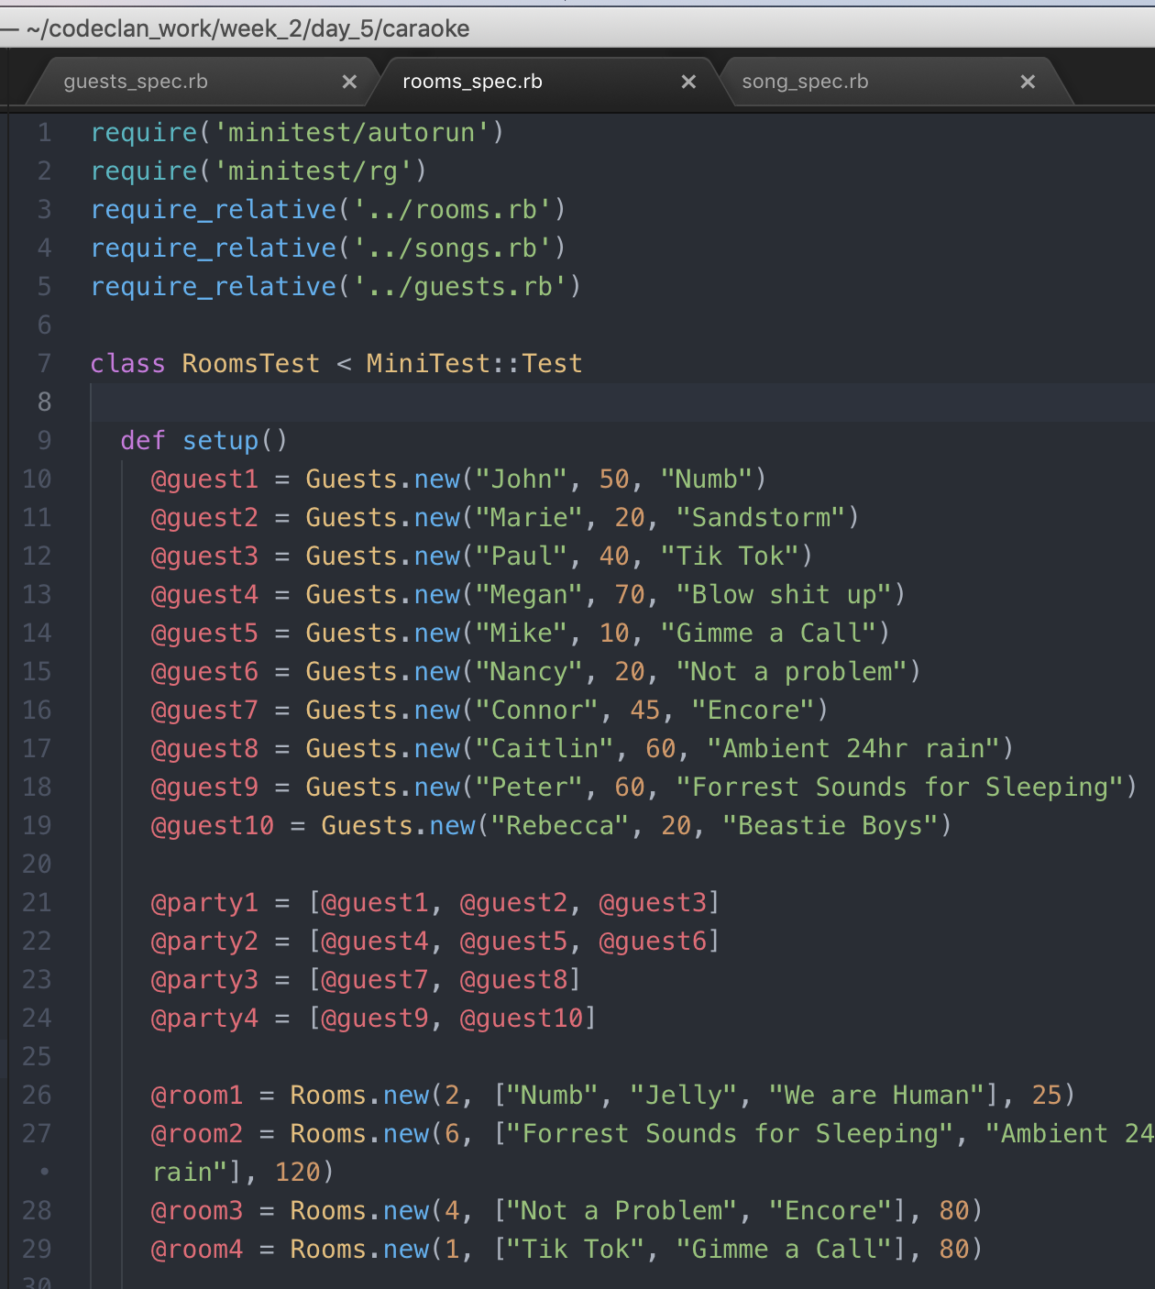

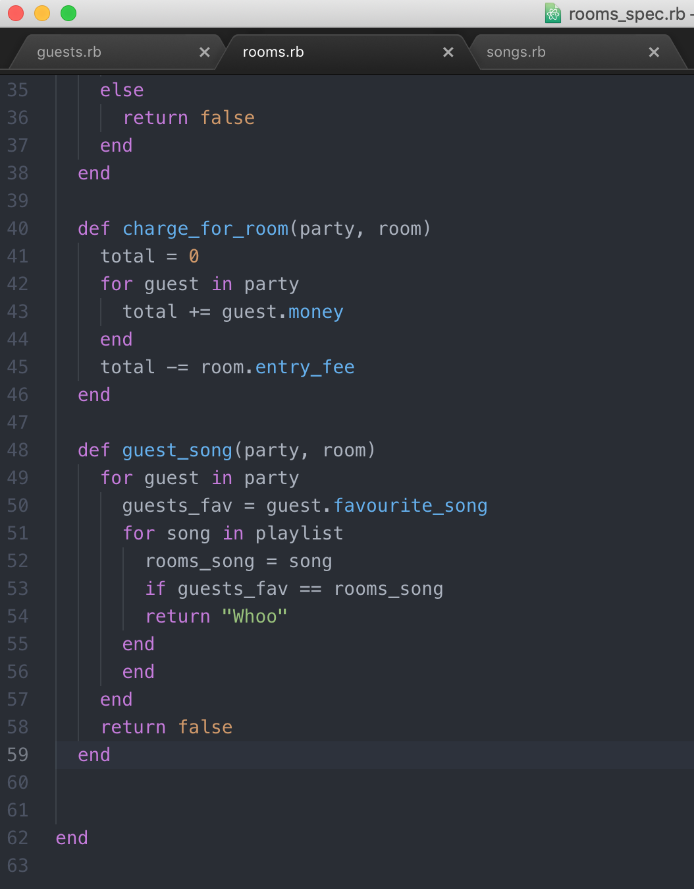

| Unit | Ref | Evidence |  |
| --- | --- | --- | --- |
| I&T | I.T.6 | Demonstrate the use of a hash in a program. Take screenshots of:  *A hash in a program  *A function that uses the hash  *The result of the function running | |
|  |  | **Description: Created a Pet Shop with customer and pets as hashes within an array. We created functions for basic operations of a pet to function, like sell pet, cash total, search for pets.** | |

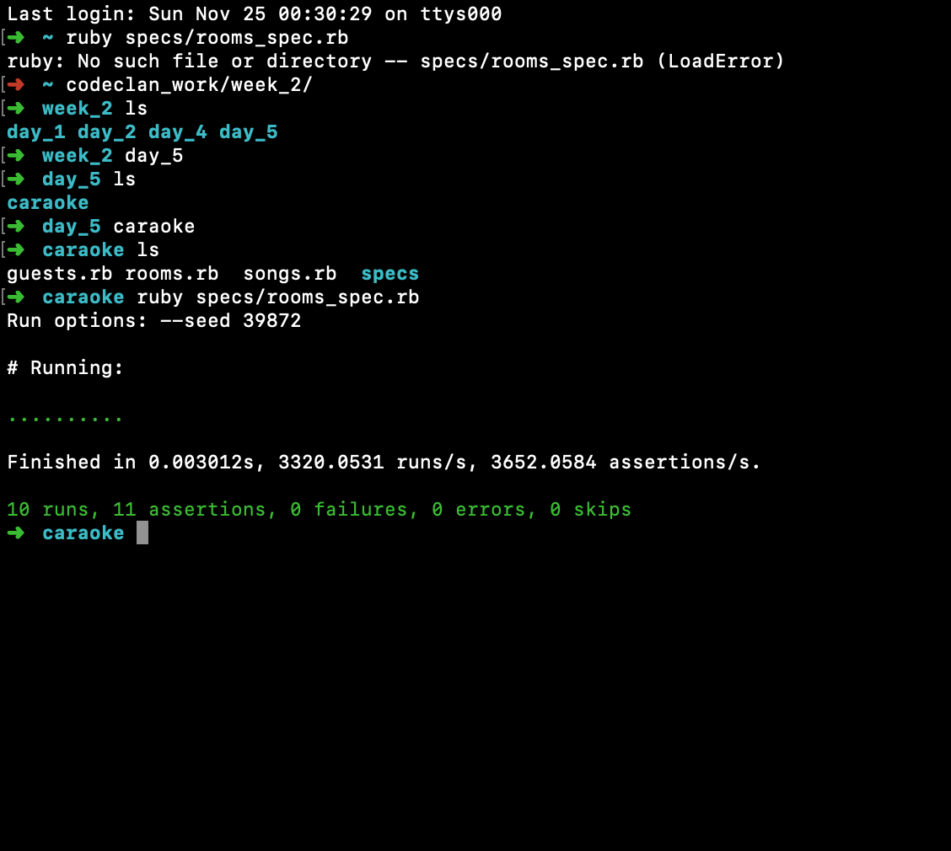

**Paste Screenshot here**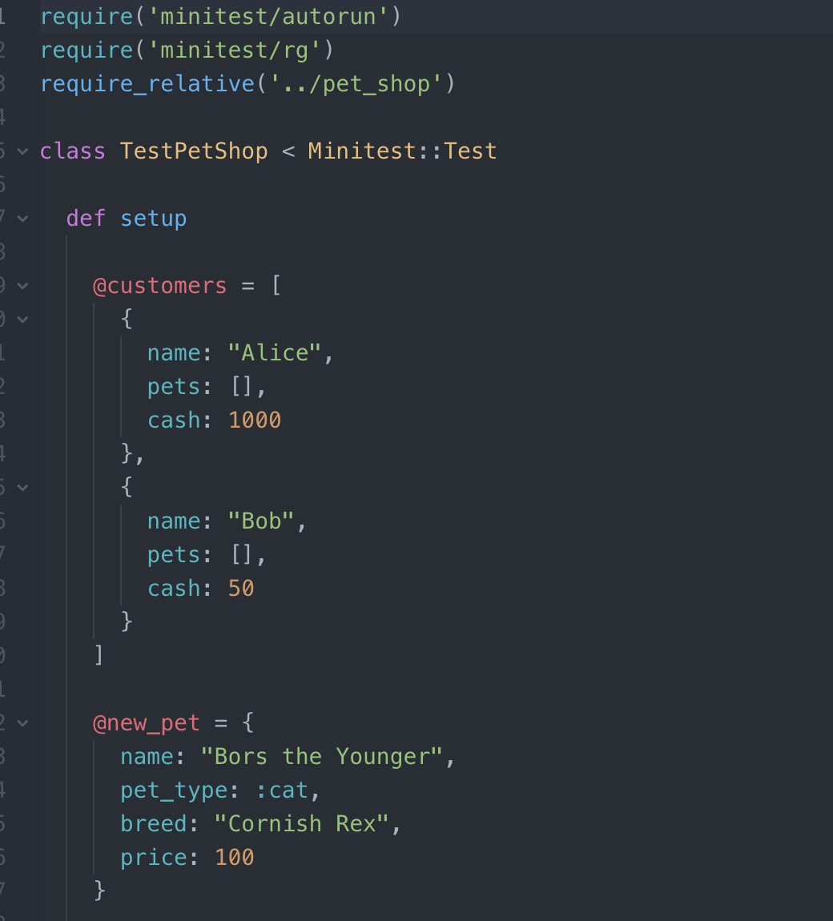

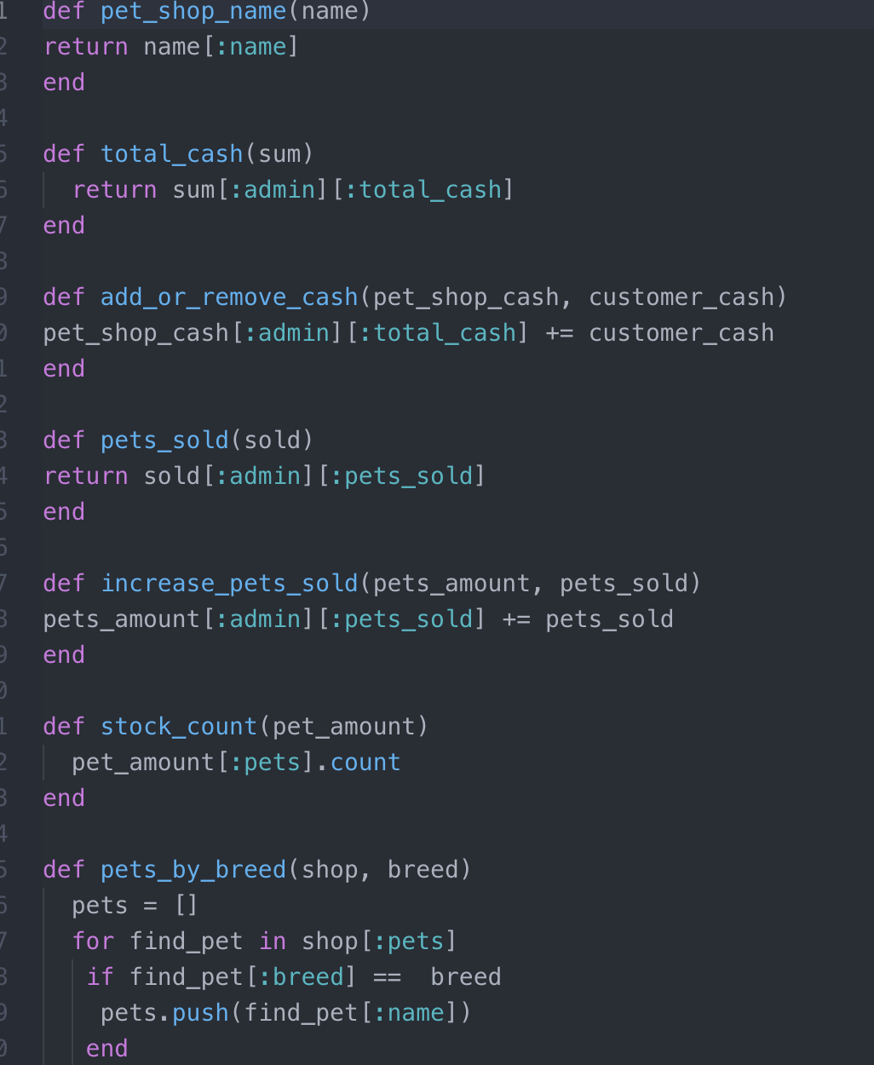

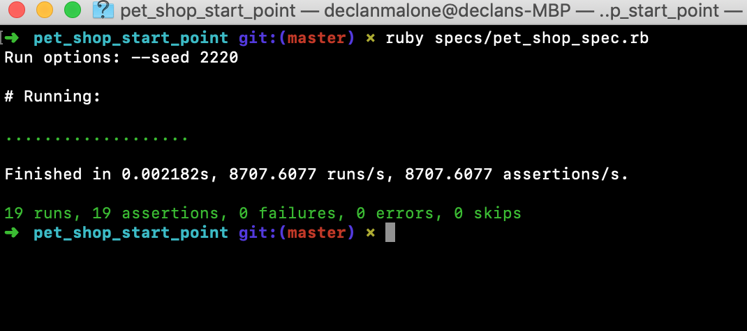

**Week 3**

| Unit | Ref | Evidence |  |
| --- | --- | --- | --- |
| I&T | I.T.3 | Demonstrate searching data in a program. Take screenshots of:  *Function that searches data  *The result of the function running | |
|  |  | **Description: I created a function within my PostgreSQL database to be able to display all of the hashes.** | |

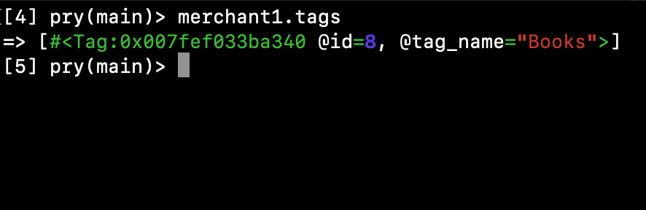

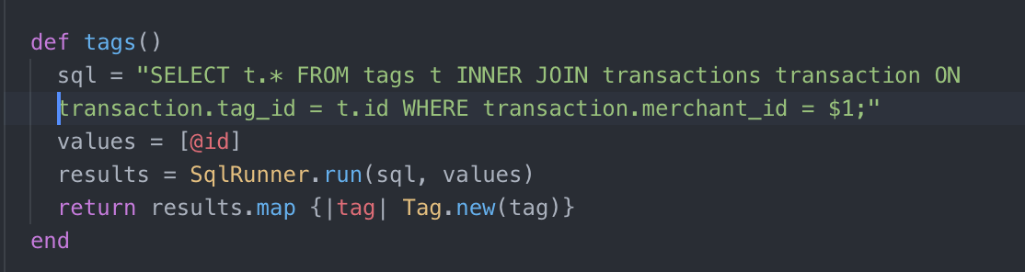

| Unit | Ref | Evidence |  |
| --- | --- | --- | --- |
| I&T | I.T.4 | Demonstrate sorting data in a program. Take screenshots of:  *Function that sorts data  *The result of the function running | |
|  |  | **Description: Using an ORDER BY function to sort data in a psql table.** | |

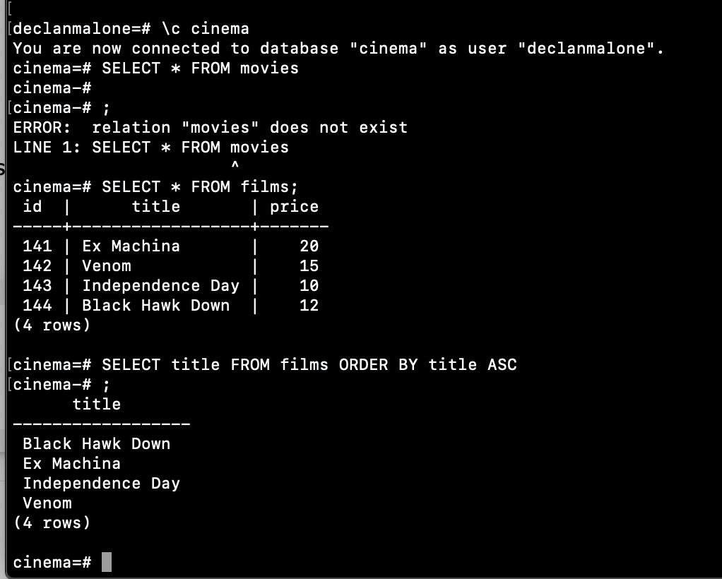

| Unit | Ref | Evidence |  |
| --- | --- | --- | --- |
| A&D | A.D.1 | A Case Diagram | |
|  |  | **Description: a flow of how my website would work** | |

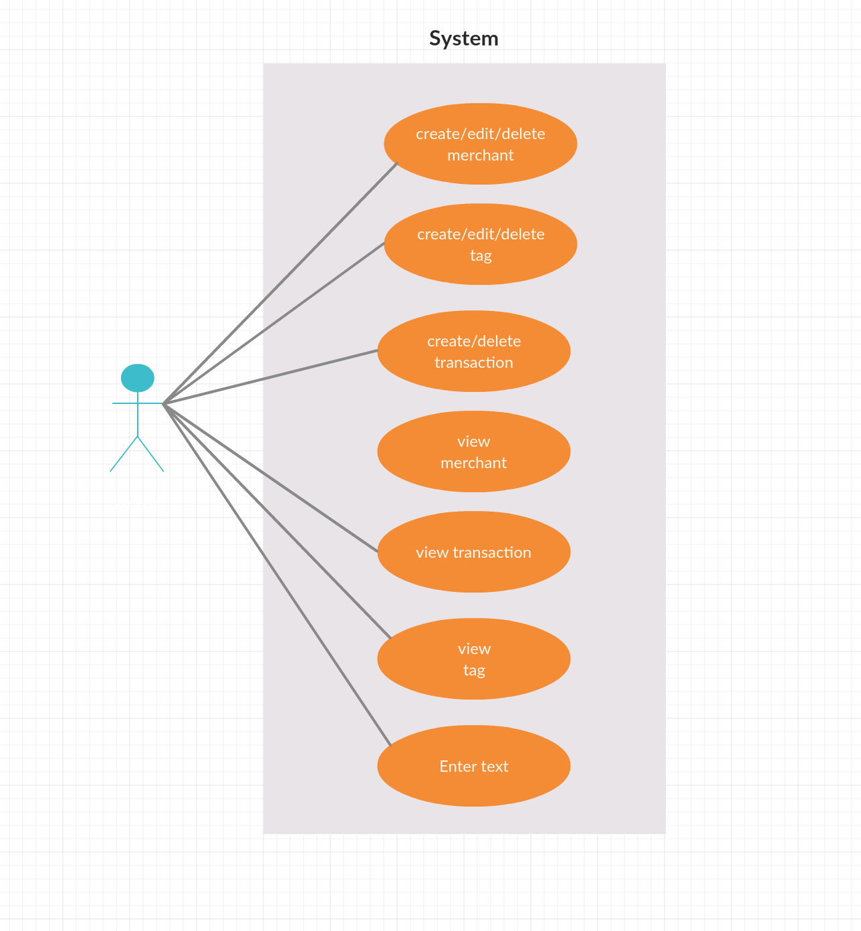

| Unit | Ref | Evidence |  |
| --- | --- | --- | --- |
| A&D | A.D.2 | A Class Diagram | |
|  |  | **Description: a diagram showing the objects classes and what is needed from the object. Objects from my spending tracker app in ruby.** | |

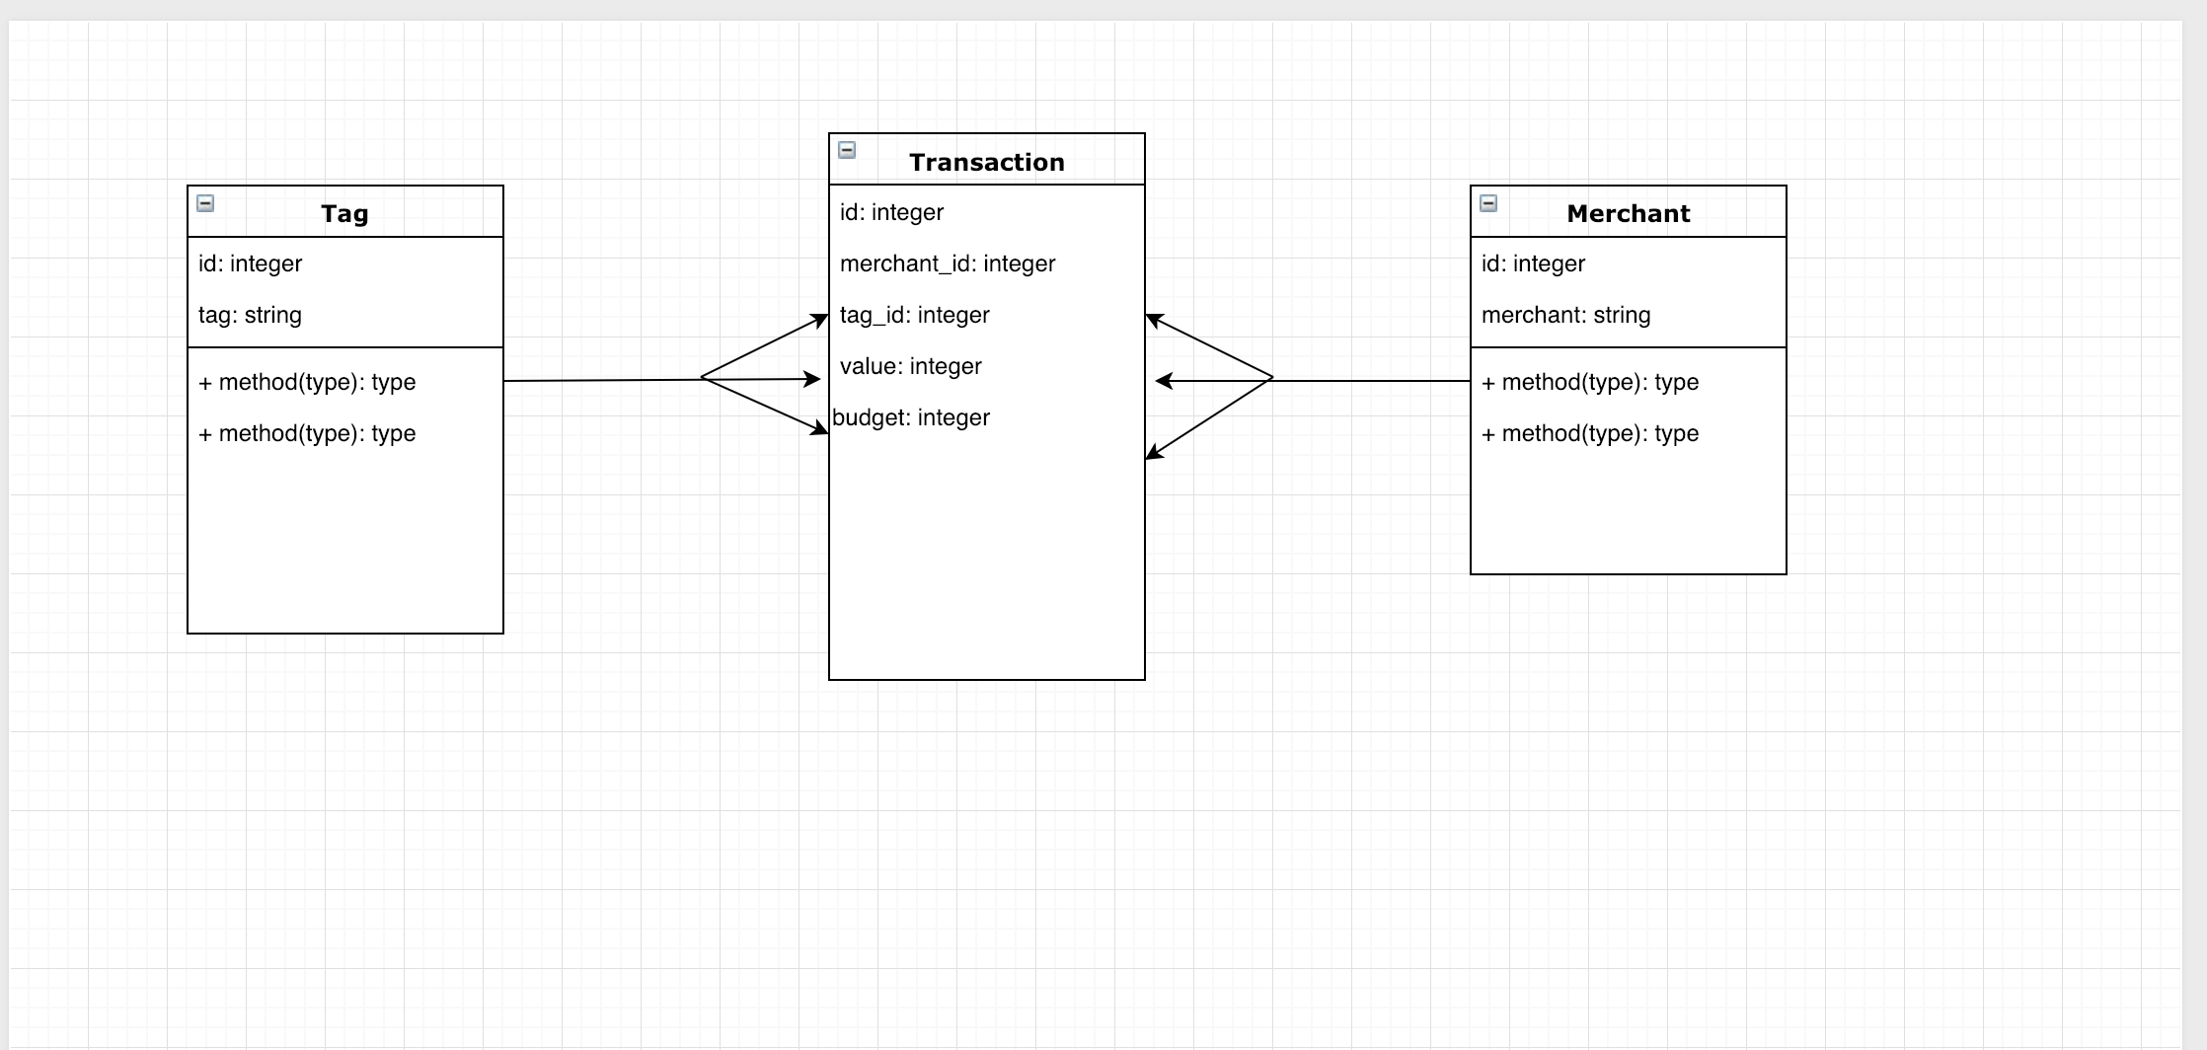

| Unit | Ref | Evidence |  |
| --- | --- | --- | --- |
| A&D | A.D.3 | An Object Diagram | |
|  |  | **Description: a diagram displaying the object properties of my spending tracker app.** | |

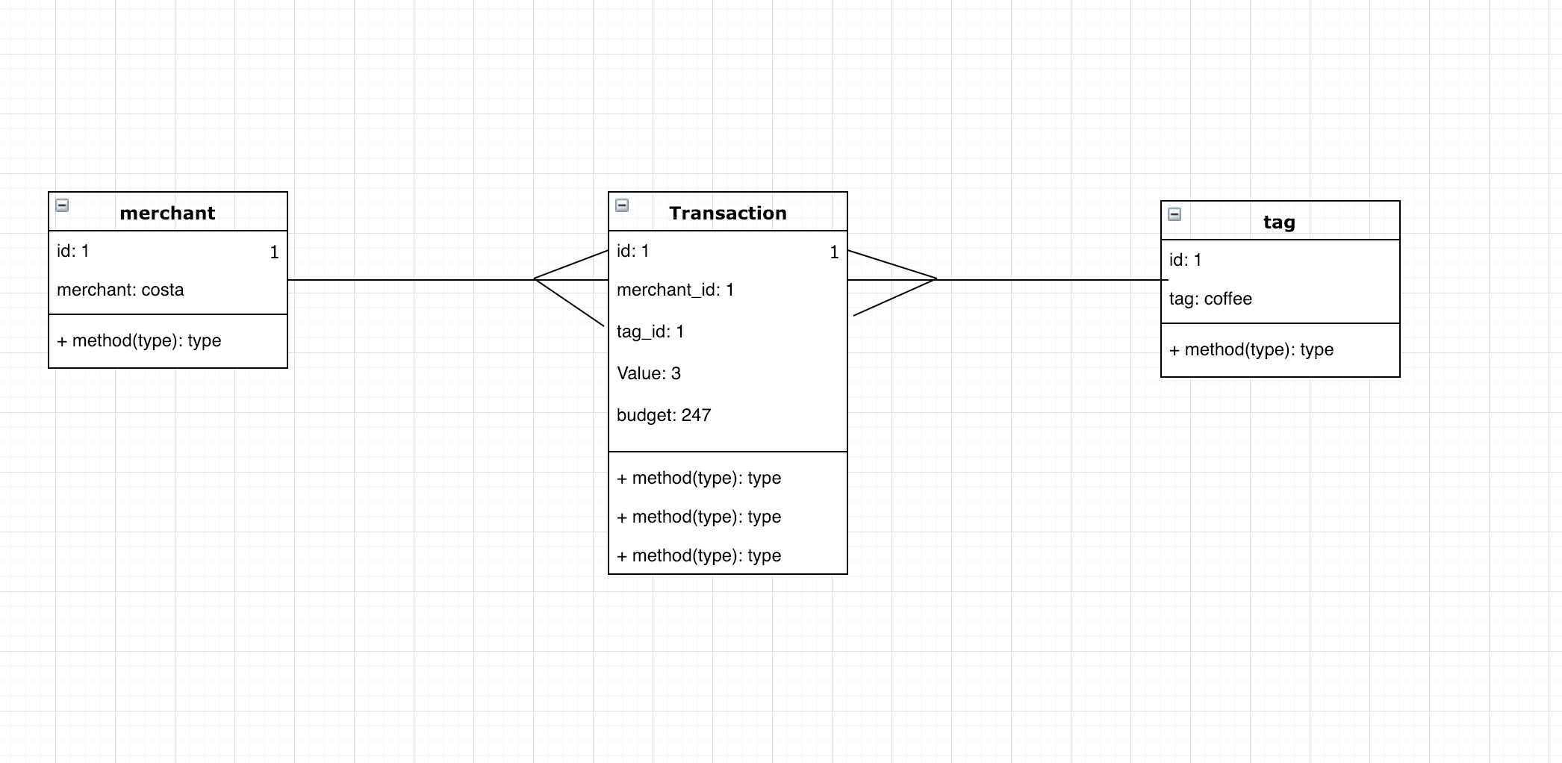

| Unit | Ref | Evidence |  |
| --- | --- | --- | --- |
| A&D | A.D.4 | An Activity Diagram | |
|  |  | **Description: A map displaying the way a user will interact with the app.** | |

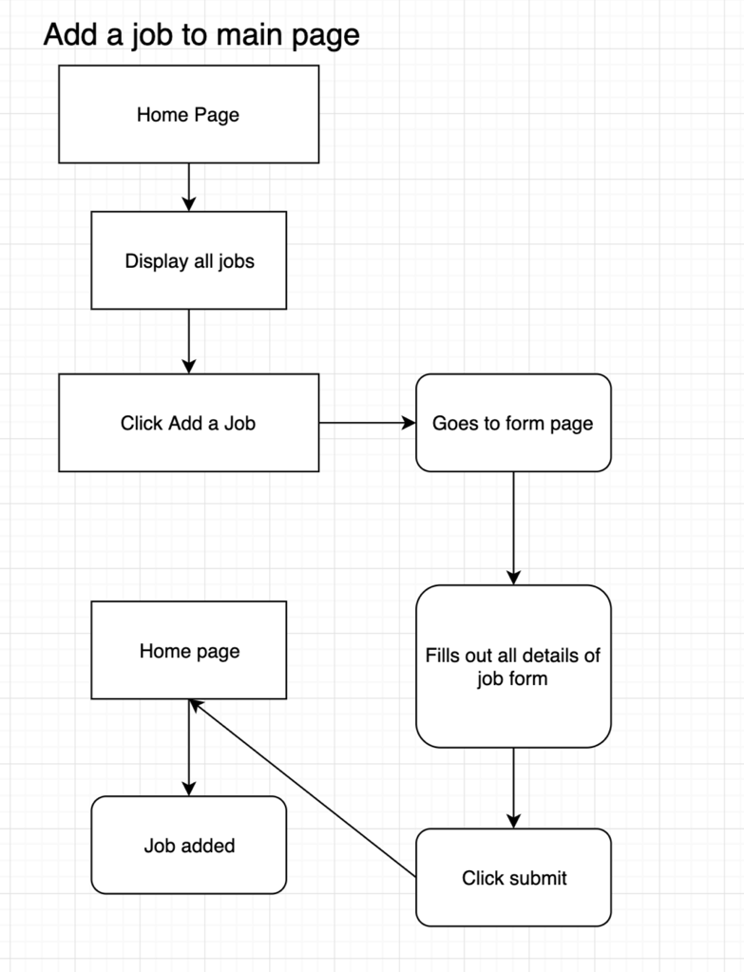

| Unit | Ref | Evidence |  |
| --- | --- | --- | --- |
| A&D | A.D.6 | Produce an Implementations Constraints plan detailing the following factors:  *Hardware and software platforms  *Performance requirements  *Persistent storage and transactions  *Usability  *Budgets  *Time | |
|  |  | **Description: implementation constraints on an app created for our JavaScript project, the recipe app.** | |

|  |  |  |
| --- | --- | --- |
| **Constraint Category** | **Implementation Constraint** | **Solution** |
| Hardware and Software Platforms | The program was written on a mac and was not considered for Microsoft platforms. It was also only tested on Google Chrome and not checked If it could work on any other browser | Make sure the program can format correctly on a Microsoft stack as well as other browsers |
| Persistence Storage and Transactions | The database was only on one computer. | Look into buying data storage externally to be hosted |
| Usability | There was no consideration to people who would have vision disabilities. Could be difficult for a selection of people to see. | Consider this in the user design and stories process |
| Time | Created issues of not people able to finish the product on time. | Extend the deadline or plan better for time management. |

| Unit | Ref | Evidence |  |
| --- | --- | --- | --- |
| P | P.5 | User Site Map | |
|  |  | **Description: A map to display the way the user will navigate the app.** | |

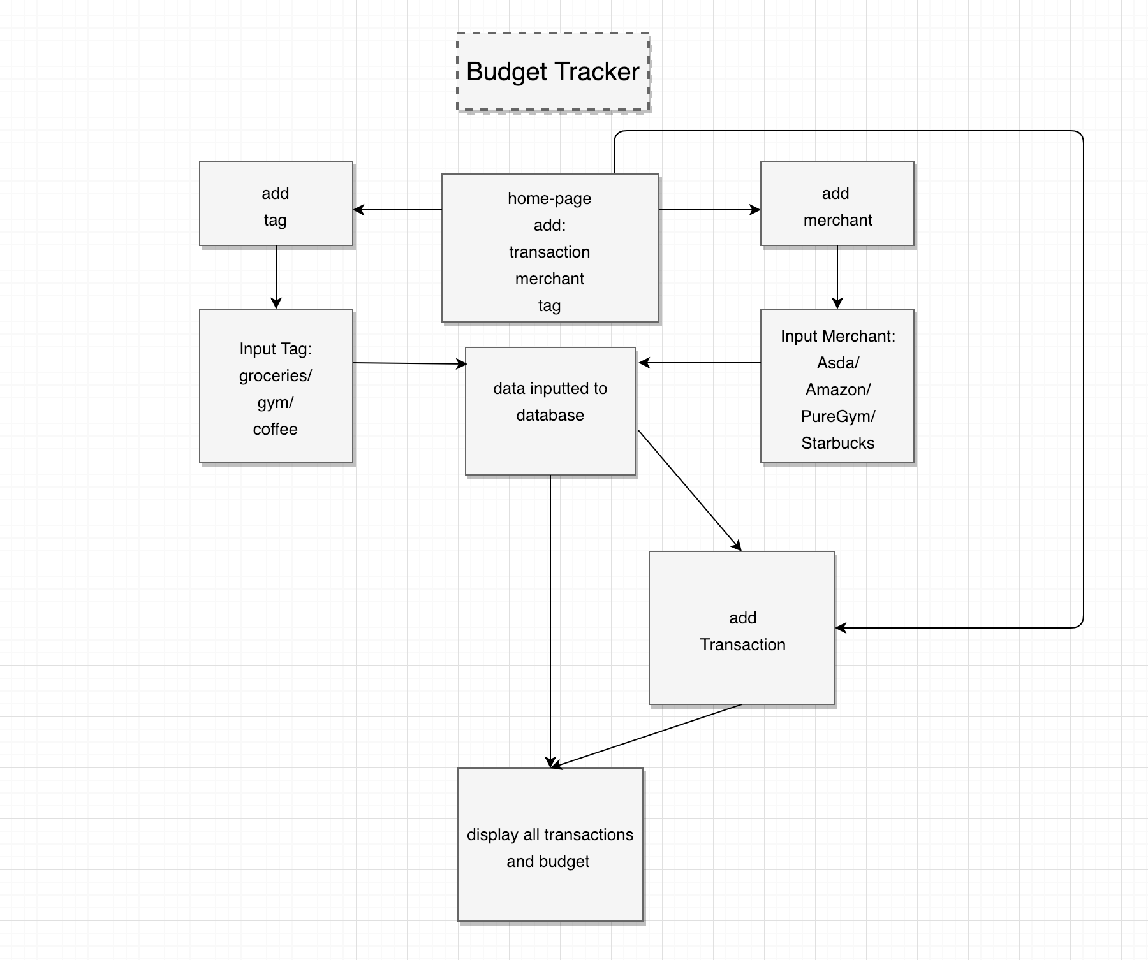

| Unit | Ref | Evidence |  |
| --- | --- | --- | --- |
| P | P.6 | 2 Wireframe Diagrams | |
|  |  | **Description: I made a spending tracker app for my first solo project. These are examples of what I my project could look like. I wanted to initially created my layout for the tracker to look like it did below but it didn’t turn out this way. As it was too complicated for the time.** | |

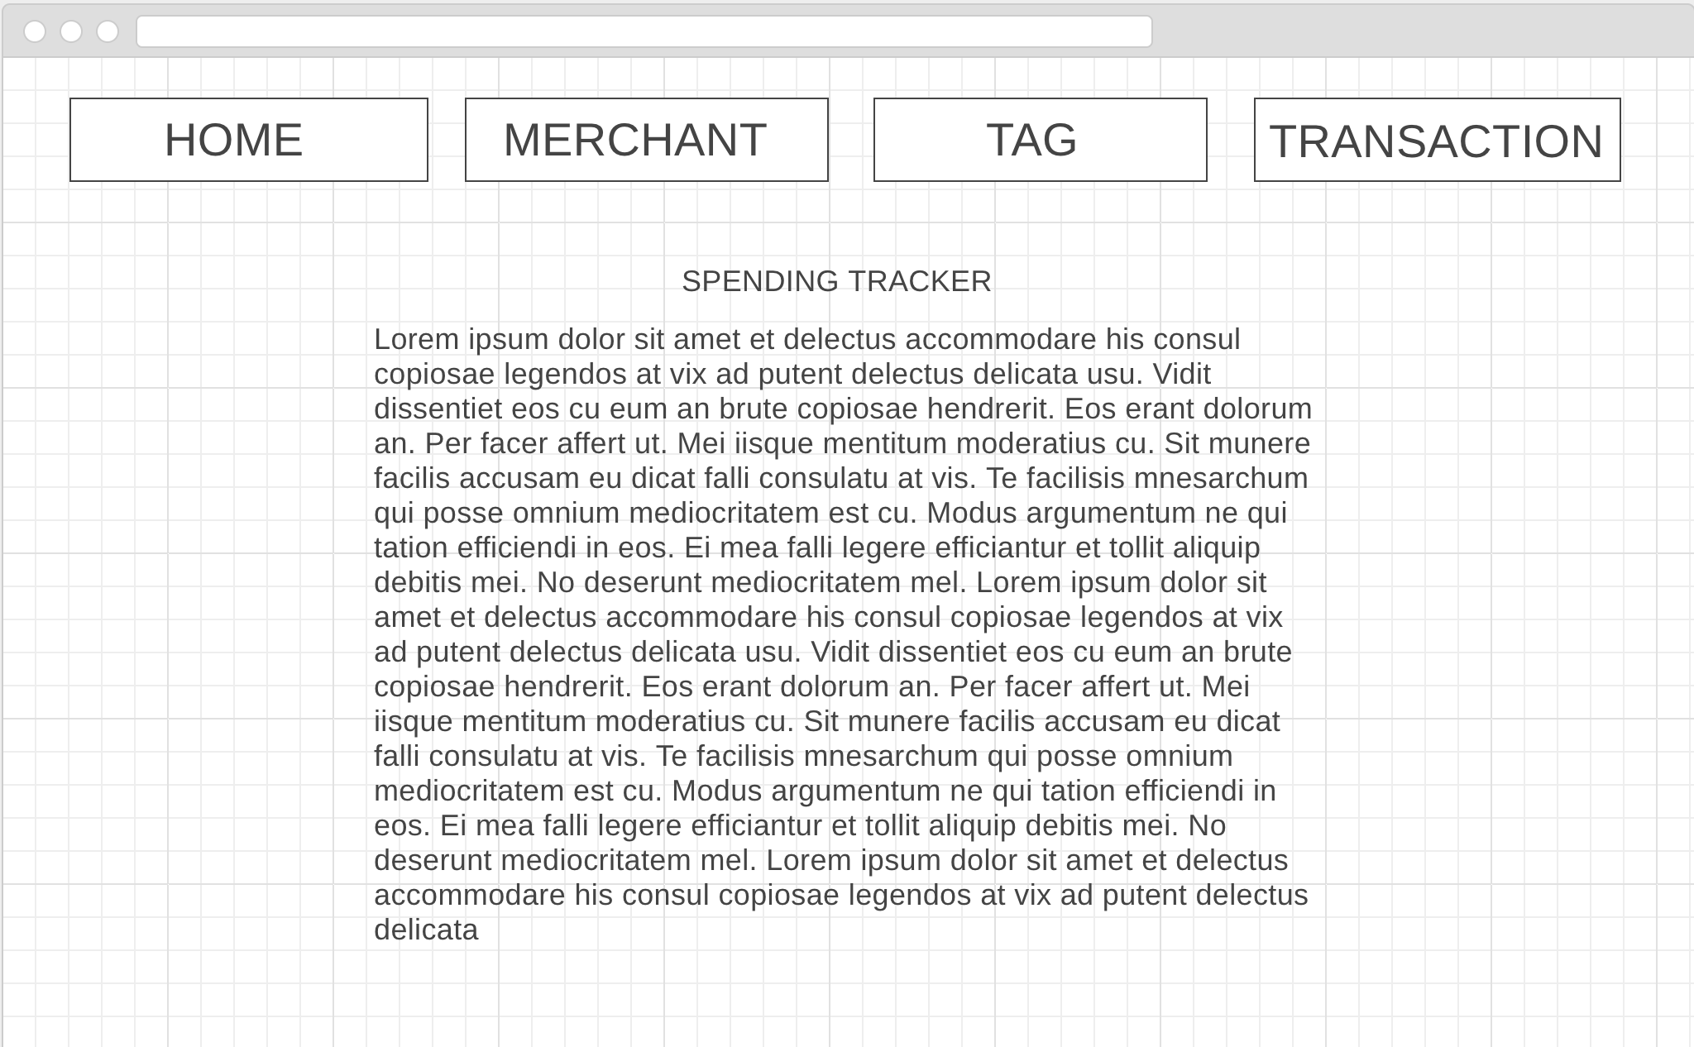

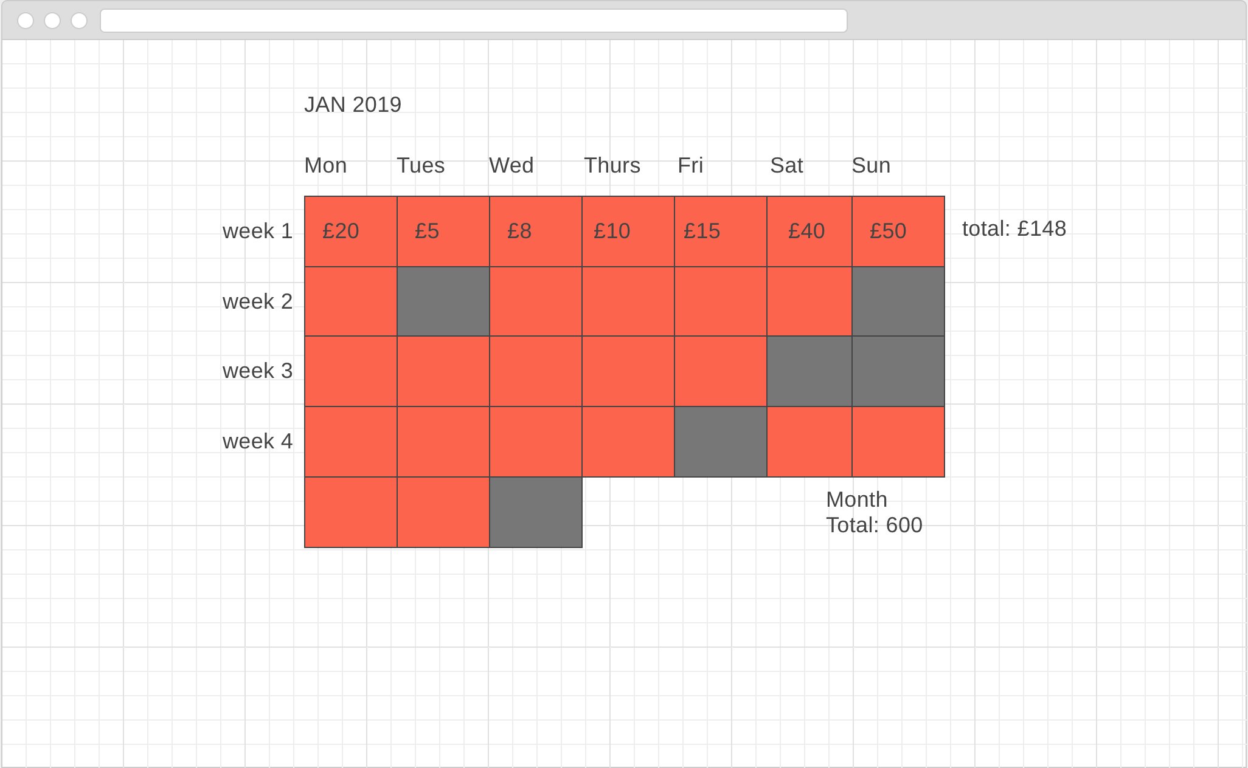

| Unit | Ref | Evidence |  |
| --- | --- | --- | --- |
| P | P.10 | Example of Pseudocode used for a method | |
|  |  | **Description: I used an inbuilt random function within Javascript to return 6 random numbers between 1 and the length of the recipes array. I then put those numbers in an array matching the index of the recipe object.** | |

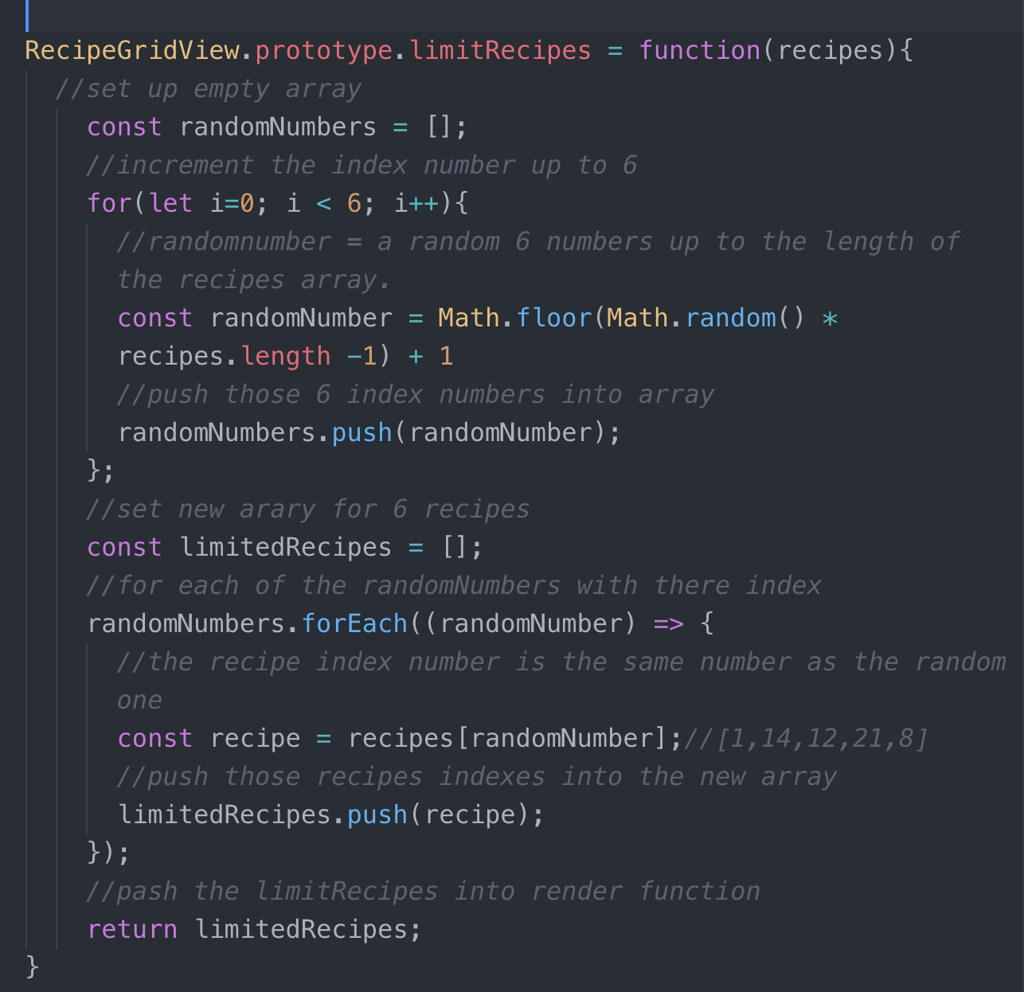

**Paste Screenshot here**

| Unit | Ref | Evidence |  |
| --- | --- | --- | --- |
| P | P.13 | Show user input being processed according to design requirements. Take a screenshot of:  * The user inputting something into your program  * The user input being saved or used in some way | |
|  |  | **Description: Inputting a merchant in my spending tracker app which stores the results in the merchant tag page.** | |

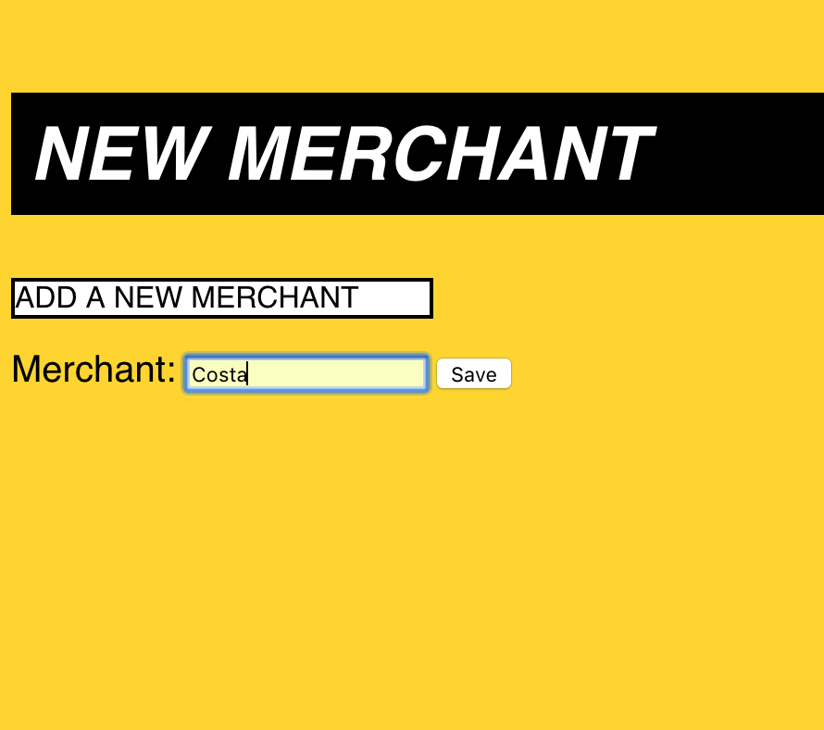

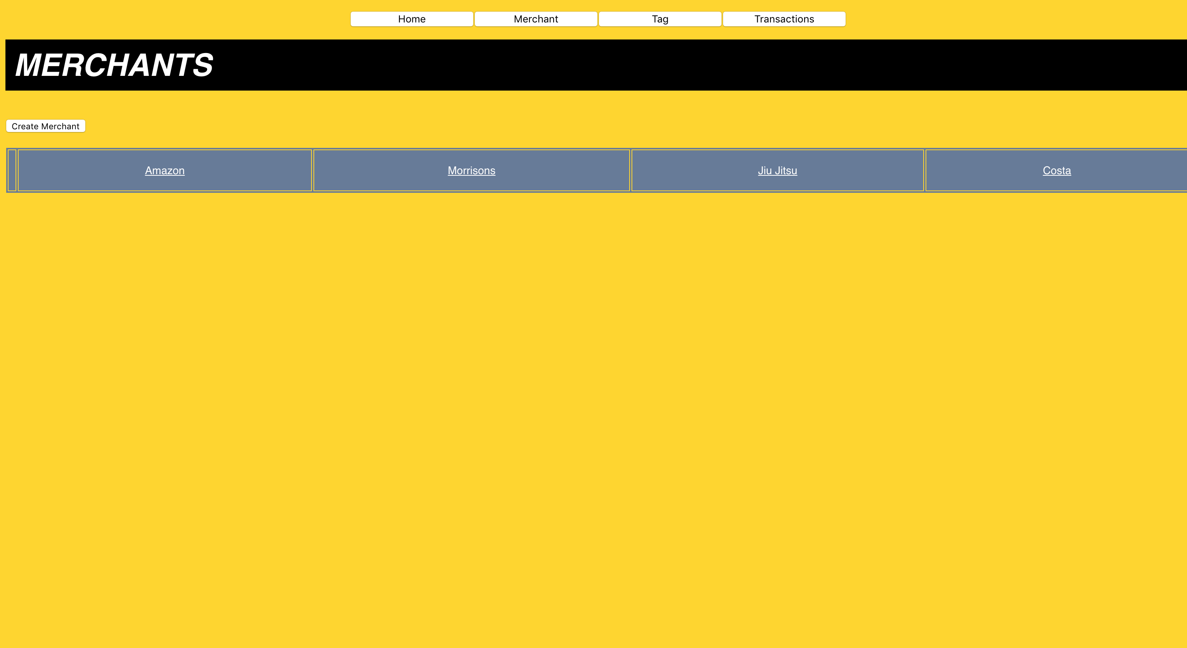

| Unit | Ref | Evidence |  |
| --- | --- | --- | --- |
| P | P.14 | Show an interaction with data persistence. Take a screenshot of:  * Data being inputted into your program  * Confirmation of the data being saved | |
|  |  | **Description: Data being stored in our recruitment app and then displayed on the page where the data should be posted to.** | |

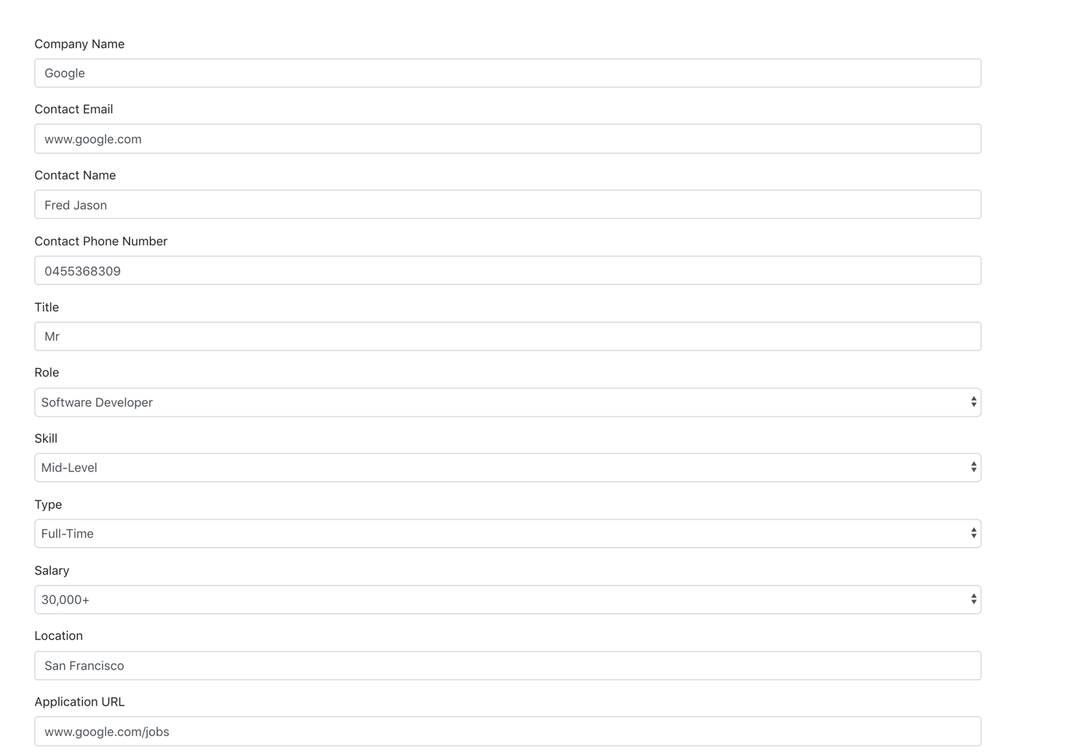

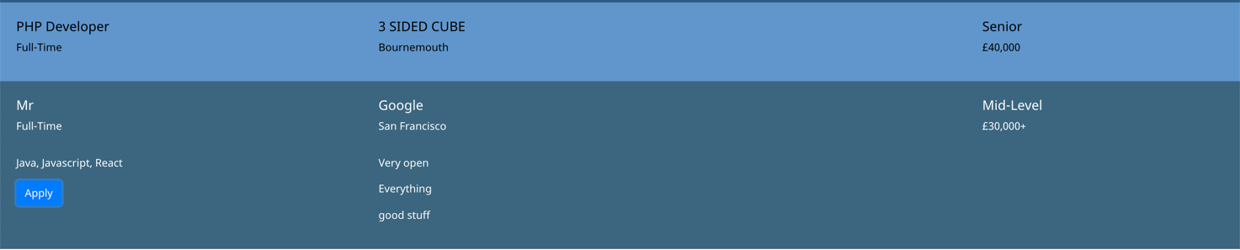



| Unit | Ref | Evidence |  |
| --- | --- | --- | --- |
| P | P.15 | Show the correct output of results and feedback to user. Take a screenshot of:  * The user requesting information or an action to be performed  * The user request being processed correctly and demonstrated in the program | |
|  |  | **Description: adding in character to specific team. Input character name specific the role, then the team which will place in a container depending on the result.** | |

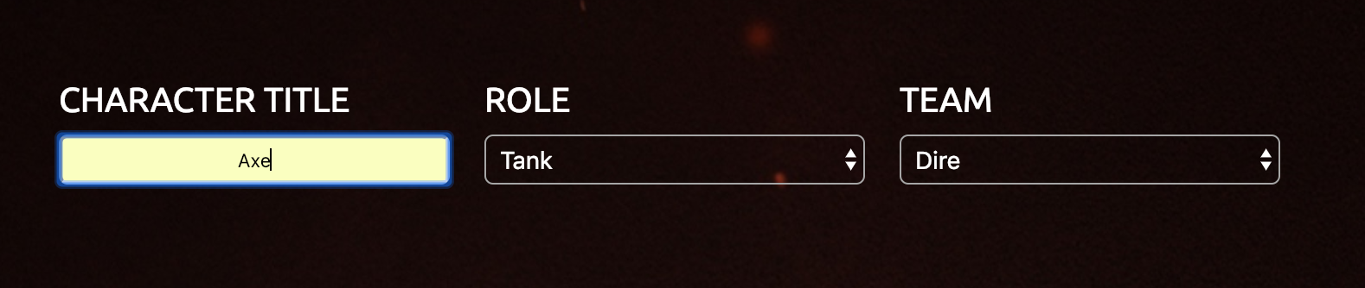

**Paste Screenshot here**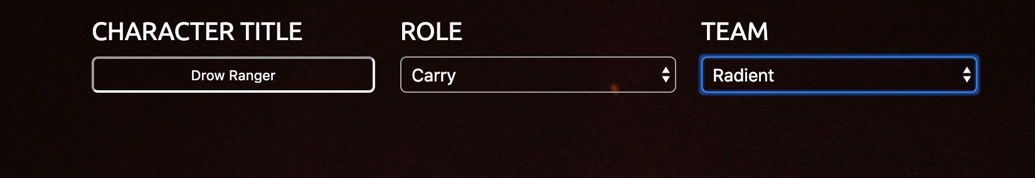

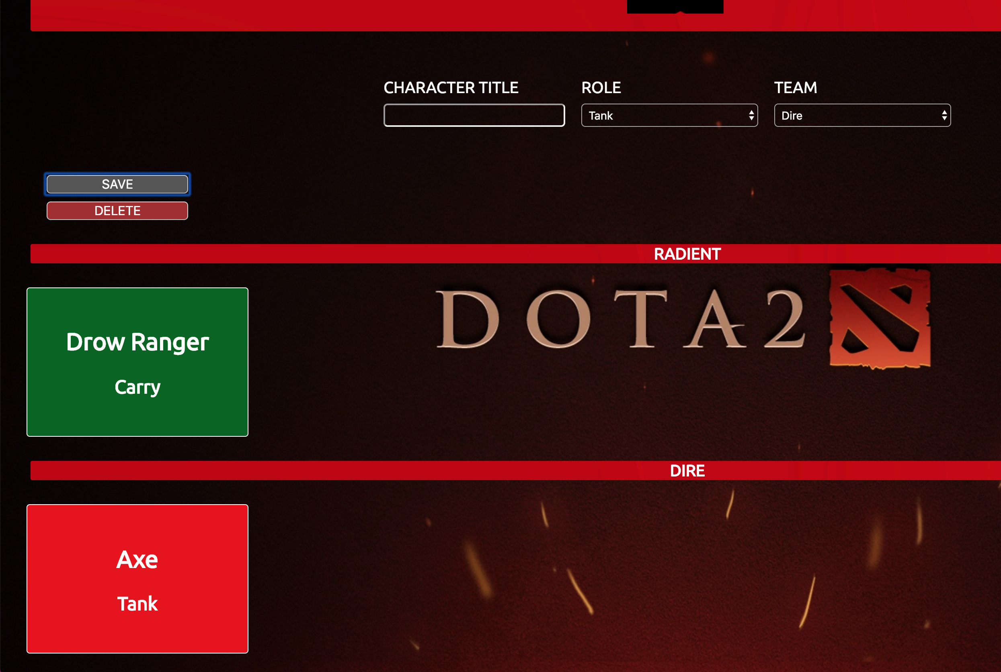

| Unit | Ref | Evidence |  |
| --- | --- | --- | --- |
| P | P.11 | Take a screenshot of one of your projects where you have worked alone and attach the Github link. | |
|  |  | **Description:** [**https://github.com/Dmalone93/Spending_Tracker**](https://github.com/Dmalone93/Spending_Tracker) | |

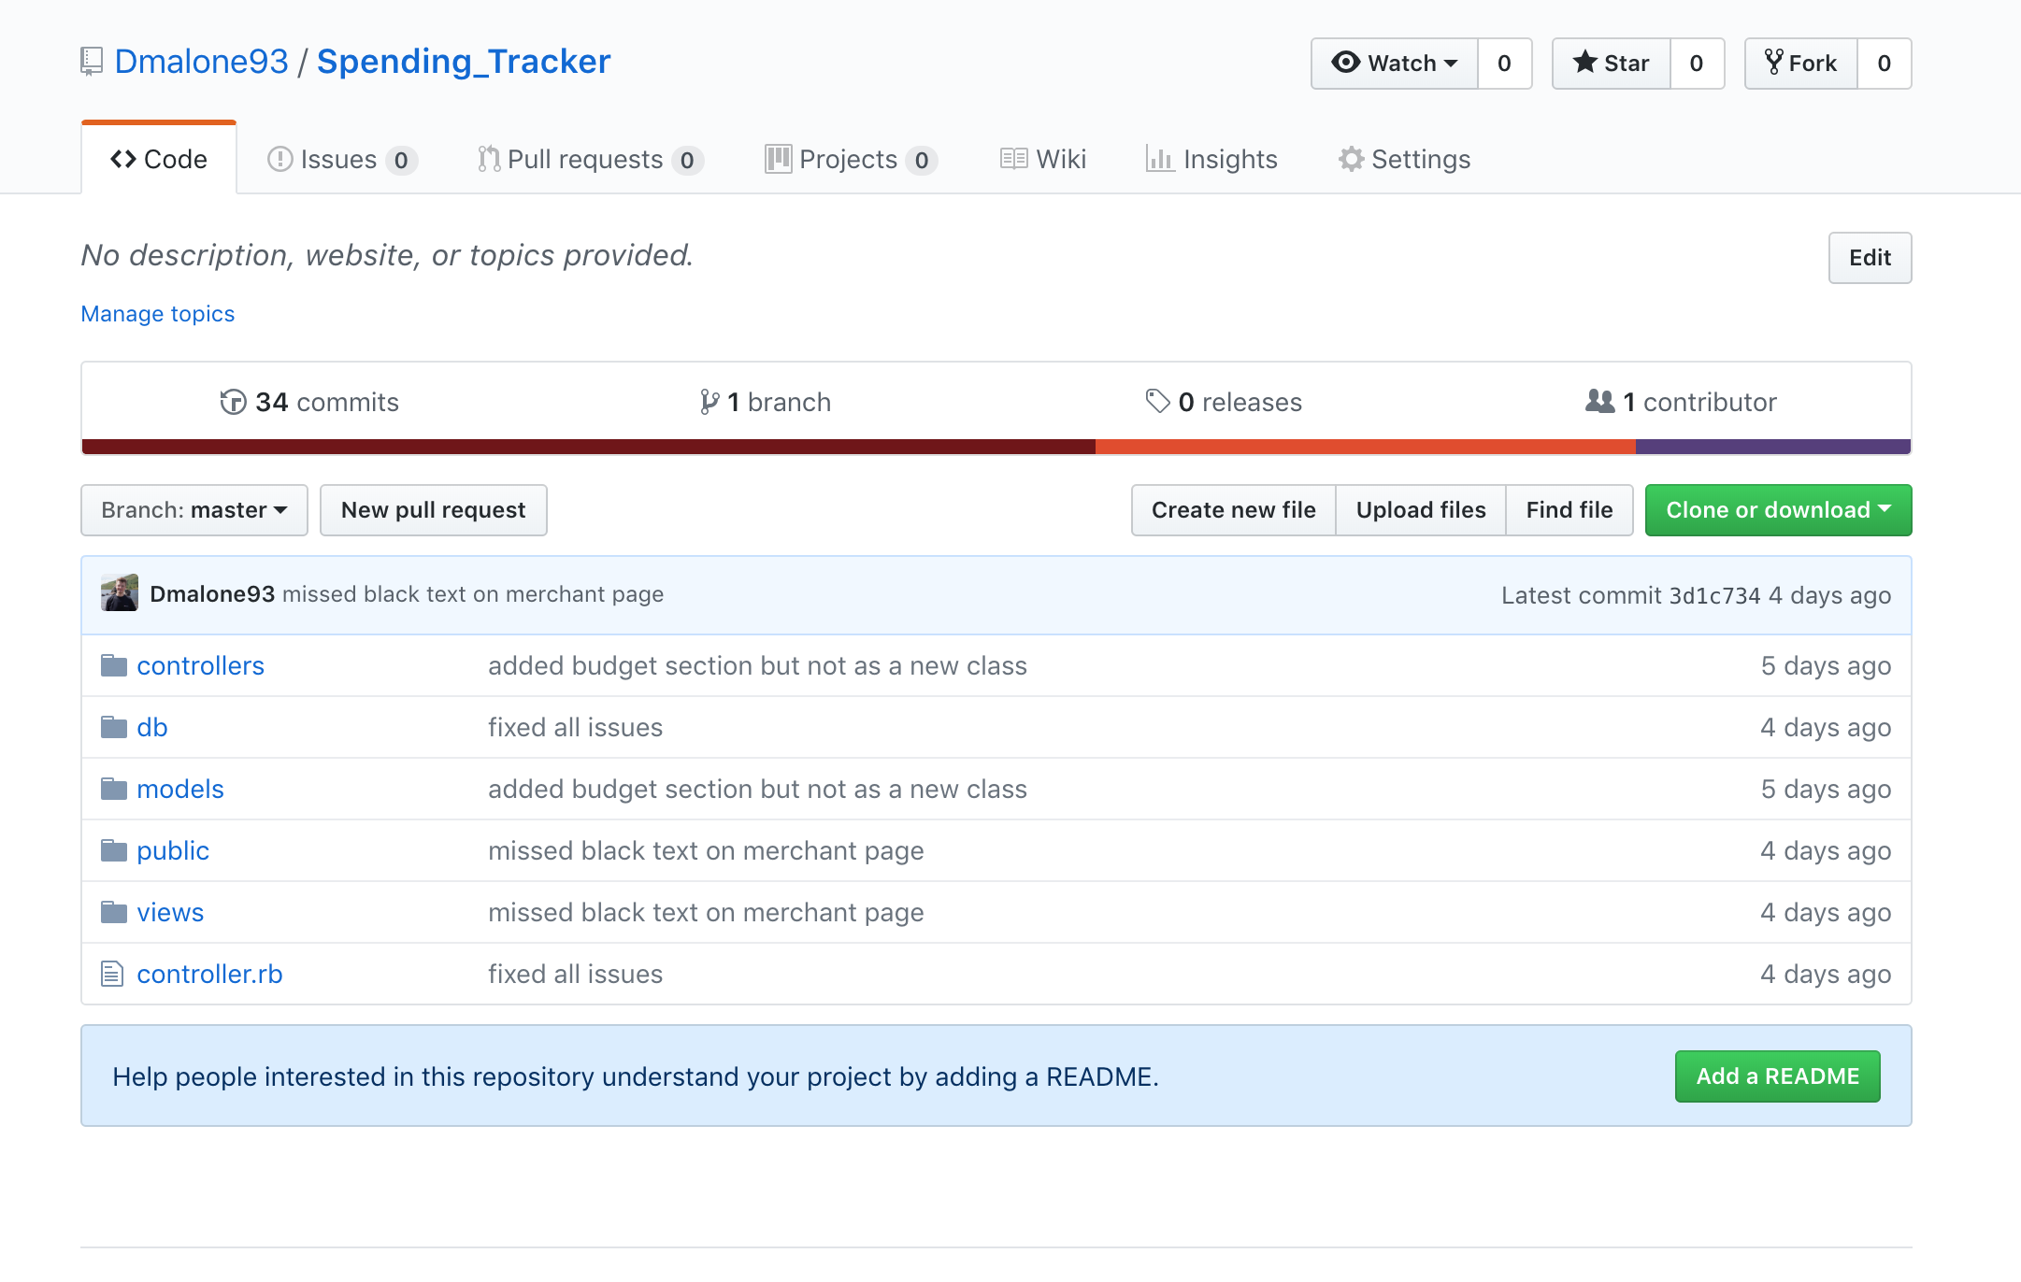

| Unit | Ref | Evidence |  |
| --- | --- | --- | --- |
| P | P.16 | Show an API being used within your program. Take a screenshot of:  * The code that uses or implements the API  * The API being used by the program whilst running | |
|  |  | **Description: I used a DOTA 2 api which is based on an online game. I used the hero name keys to populate the first dropdown to select a character. Below follows my request to the API data and the web pack npm that is updating the changes** | |

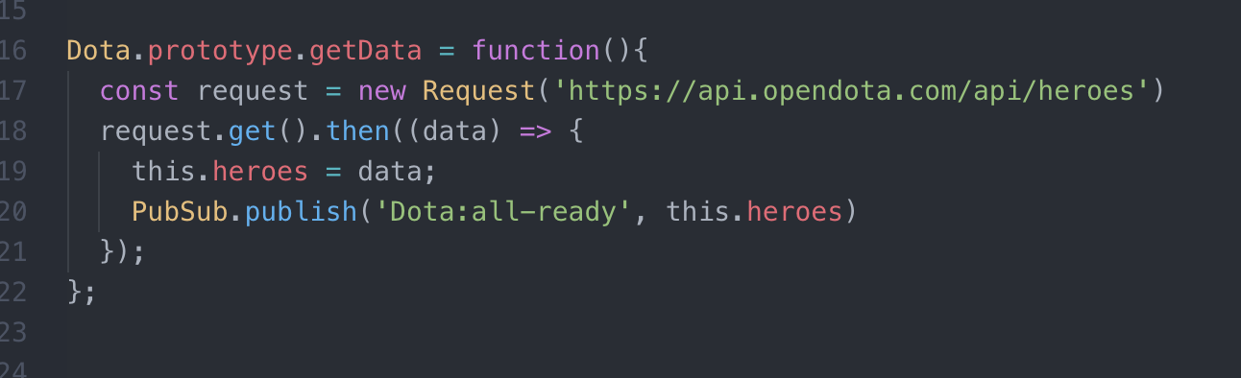

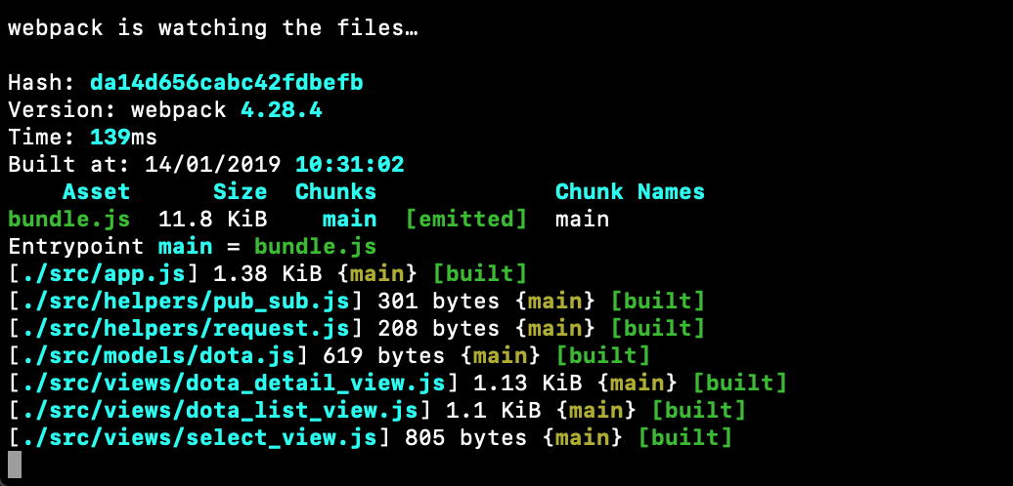

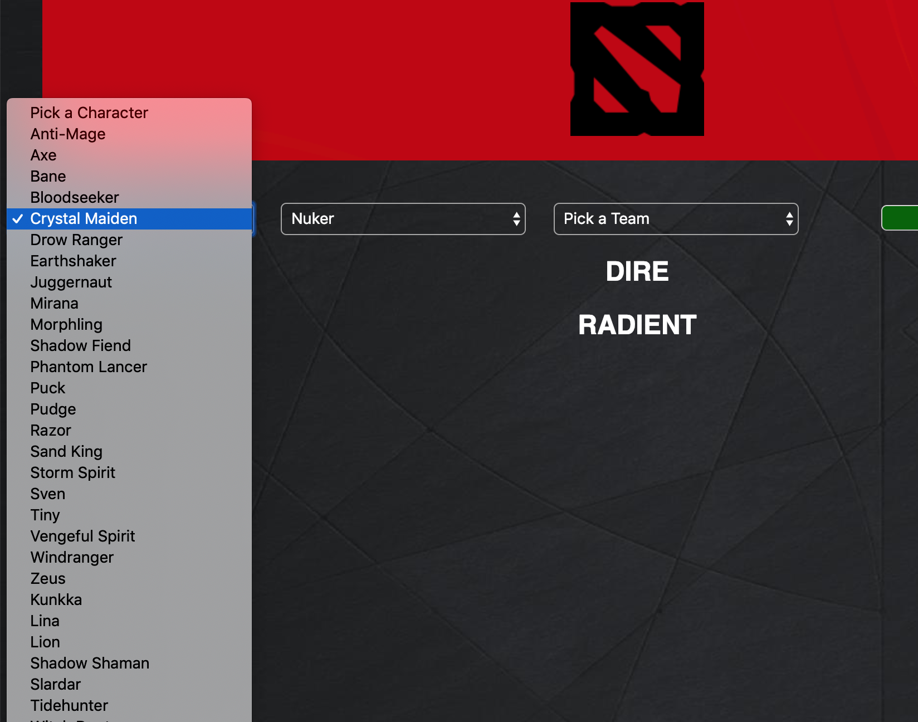

| Unit | Ref | Evidence |  |
| --- | --- | --- | --- |
| P | P.18 | Demonstrate testing in your program. Take screenshots of:  * Example of test code  * The test code failing to pass  * Example of the test code once errors have been corrected  * The test code passing | |
|  |  | **Description: test code running in top screenshot and then test code passing.** | |

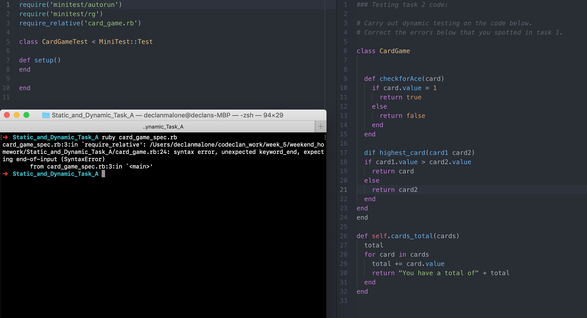

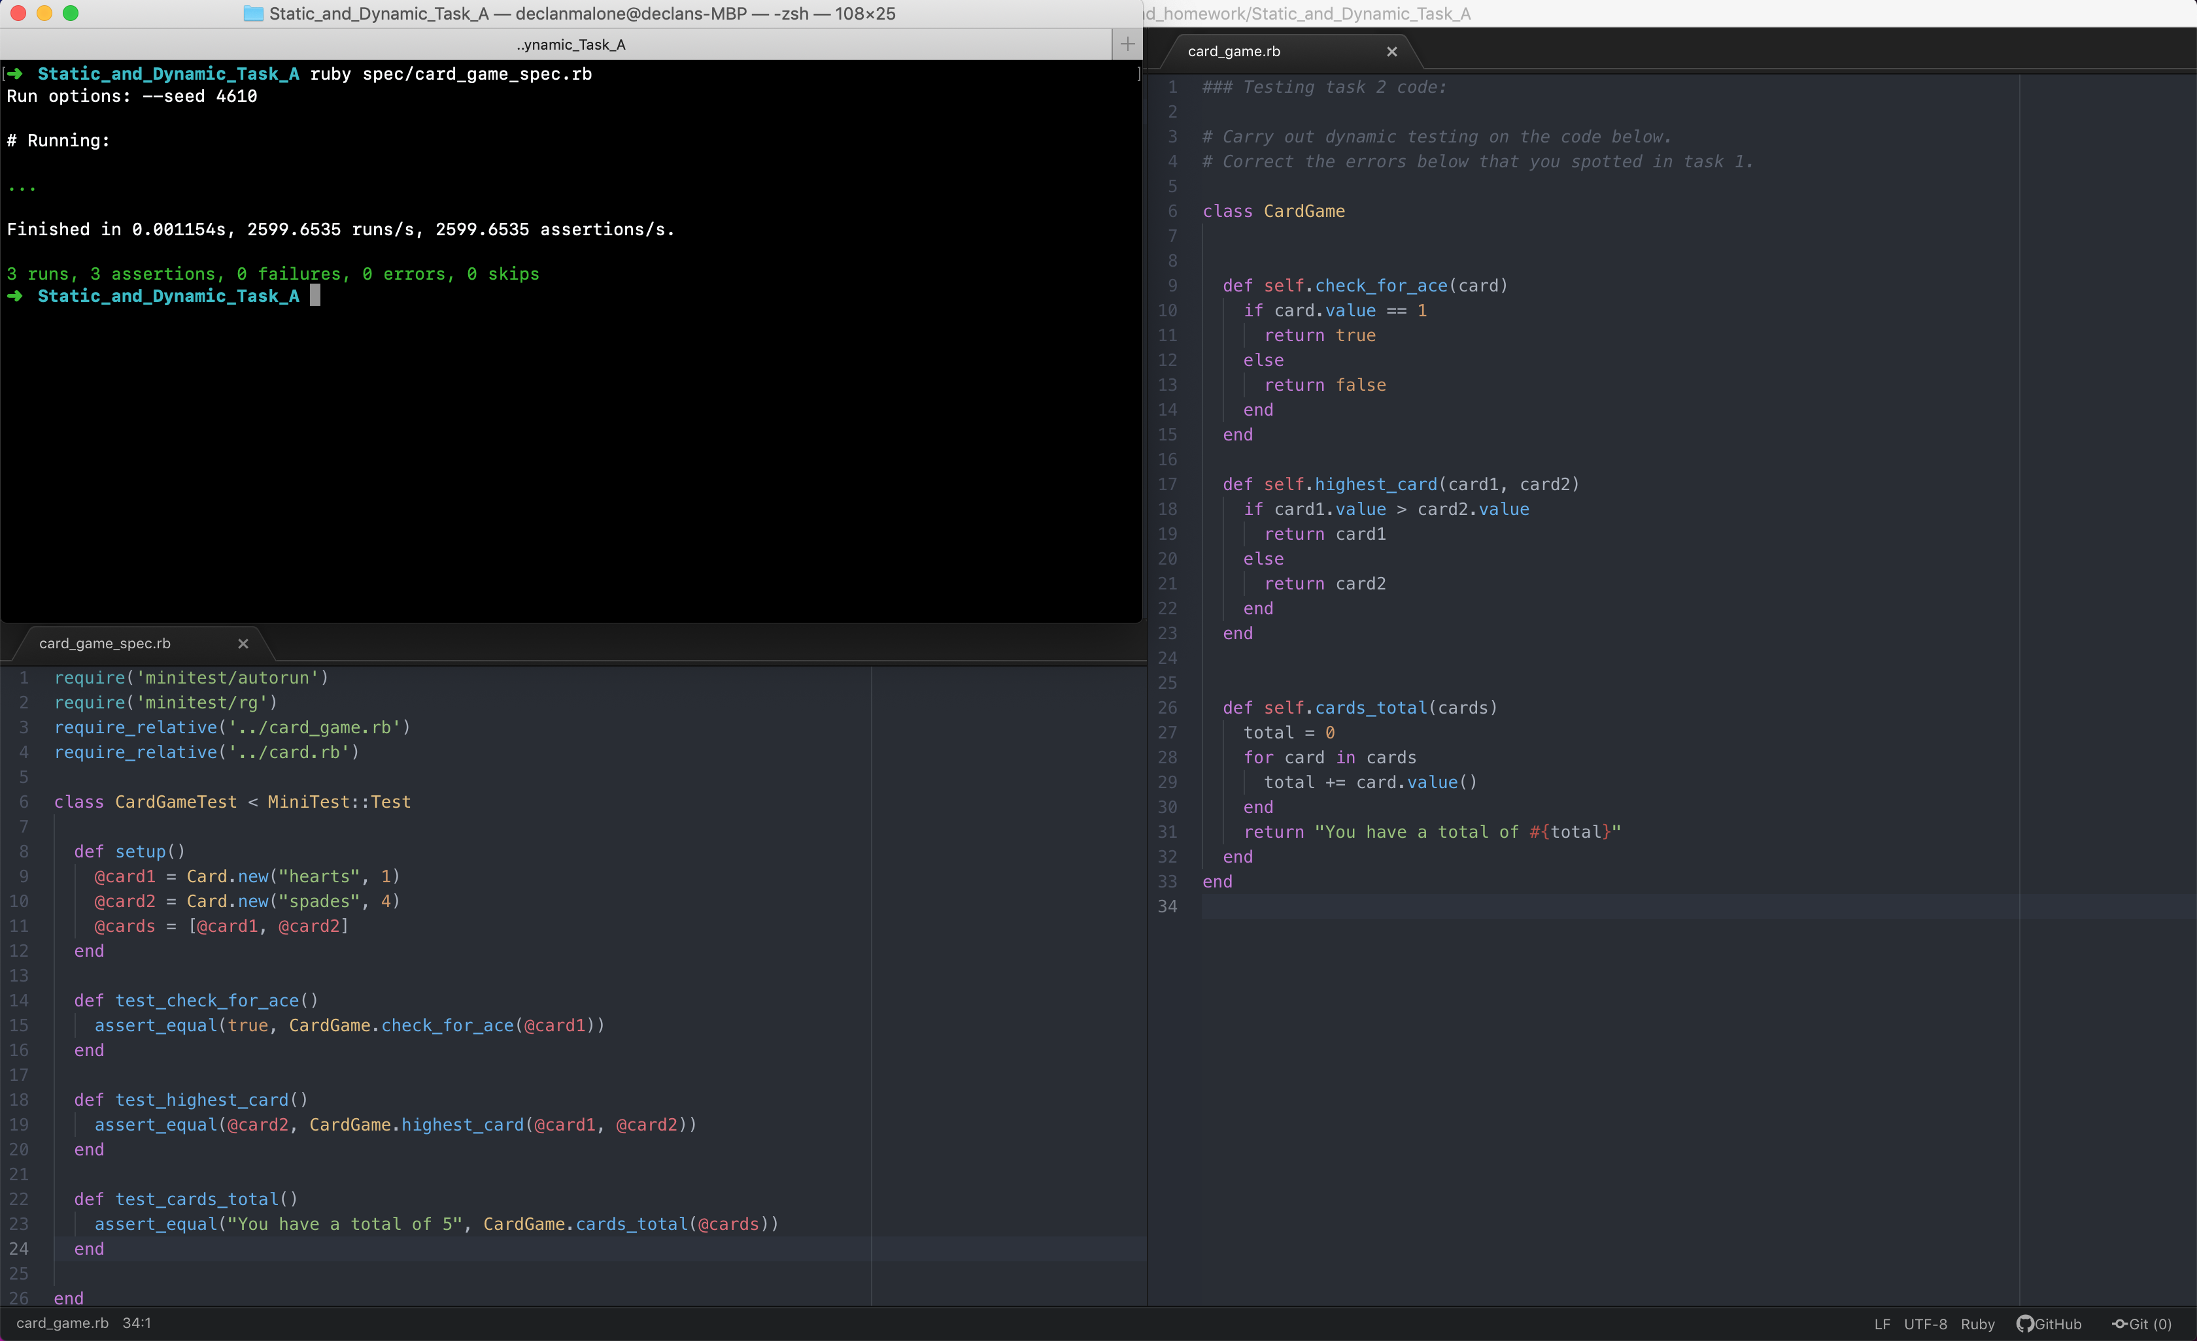

**Week 9**

| Unit | Ref | Evidence |  |
| --- | --- | --- | --- |
| P | P.1 | Take a screenshot of the contributor’s page on Github from your group project to show the team you worked with. | |
|  |  | **Description: GitHub contributors team and their activity** | |

**Paste Screenshot here**

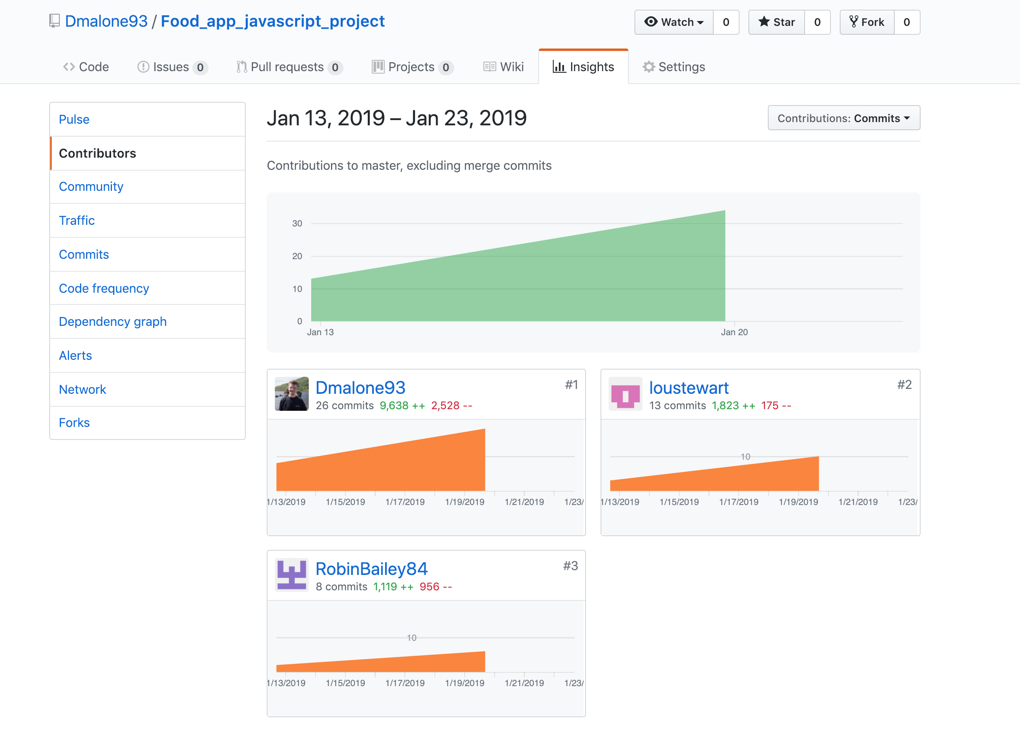

| Unit | Ref | Evidence |  |
| --- | --- | --- | --- |
| P | P.12 | Take screenshots or photos of your planning and the different stages of development to show changes. | |
|  |  | **Description: wireframe layout of our web app. Then moved onto data flow/interaction between client** | |



| Unit | Ref | Evidence |  |
| --- | --- | --- | --- |
| P | P.2 | Take a screenshot of the project brief from your group project. | |
|  |  | **Description: group project in javascript module. This involved 2 other members from the cohort.** | |

**Paste Screenshot here**

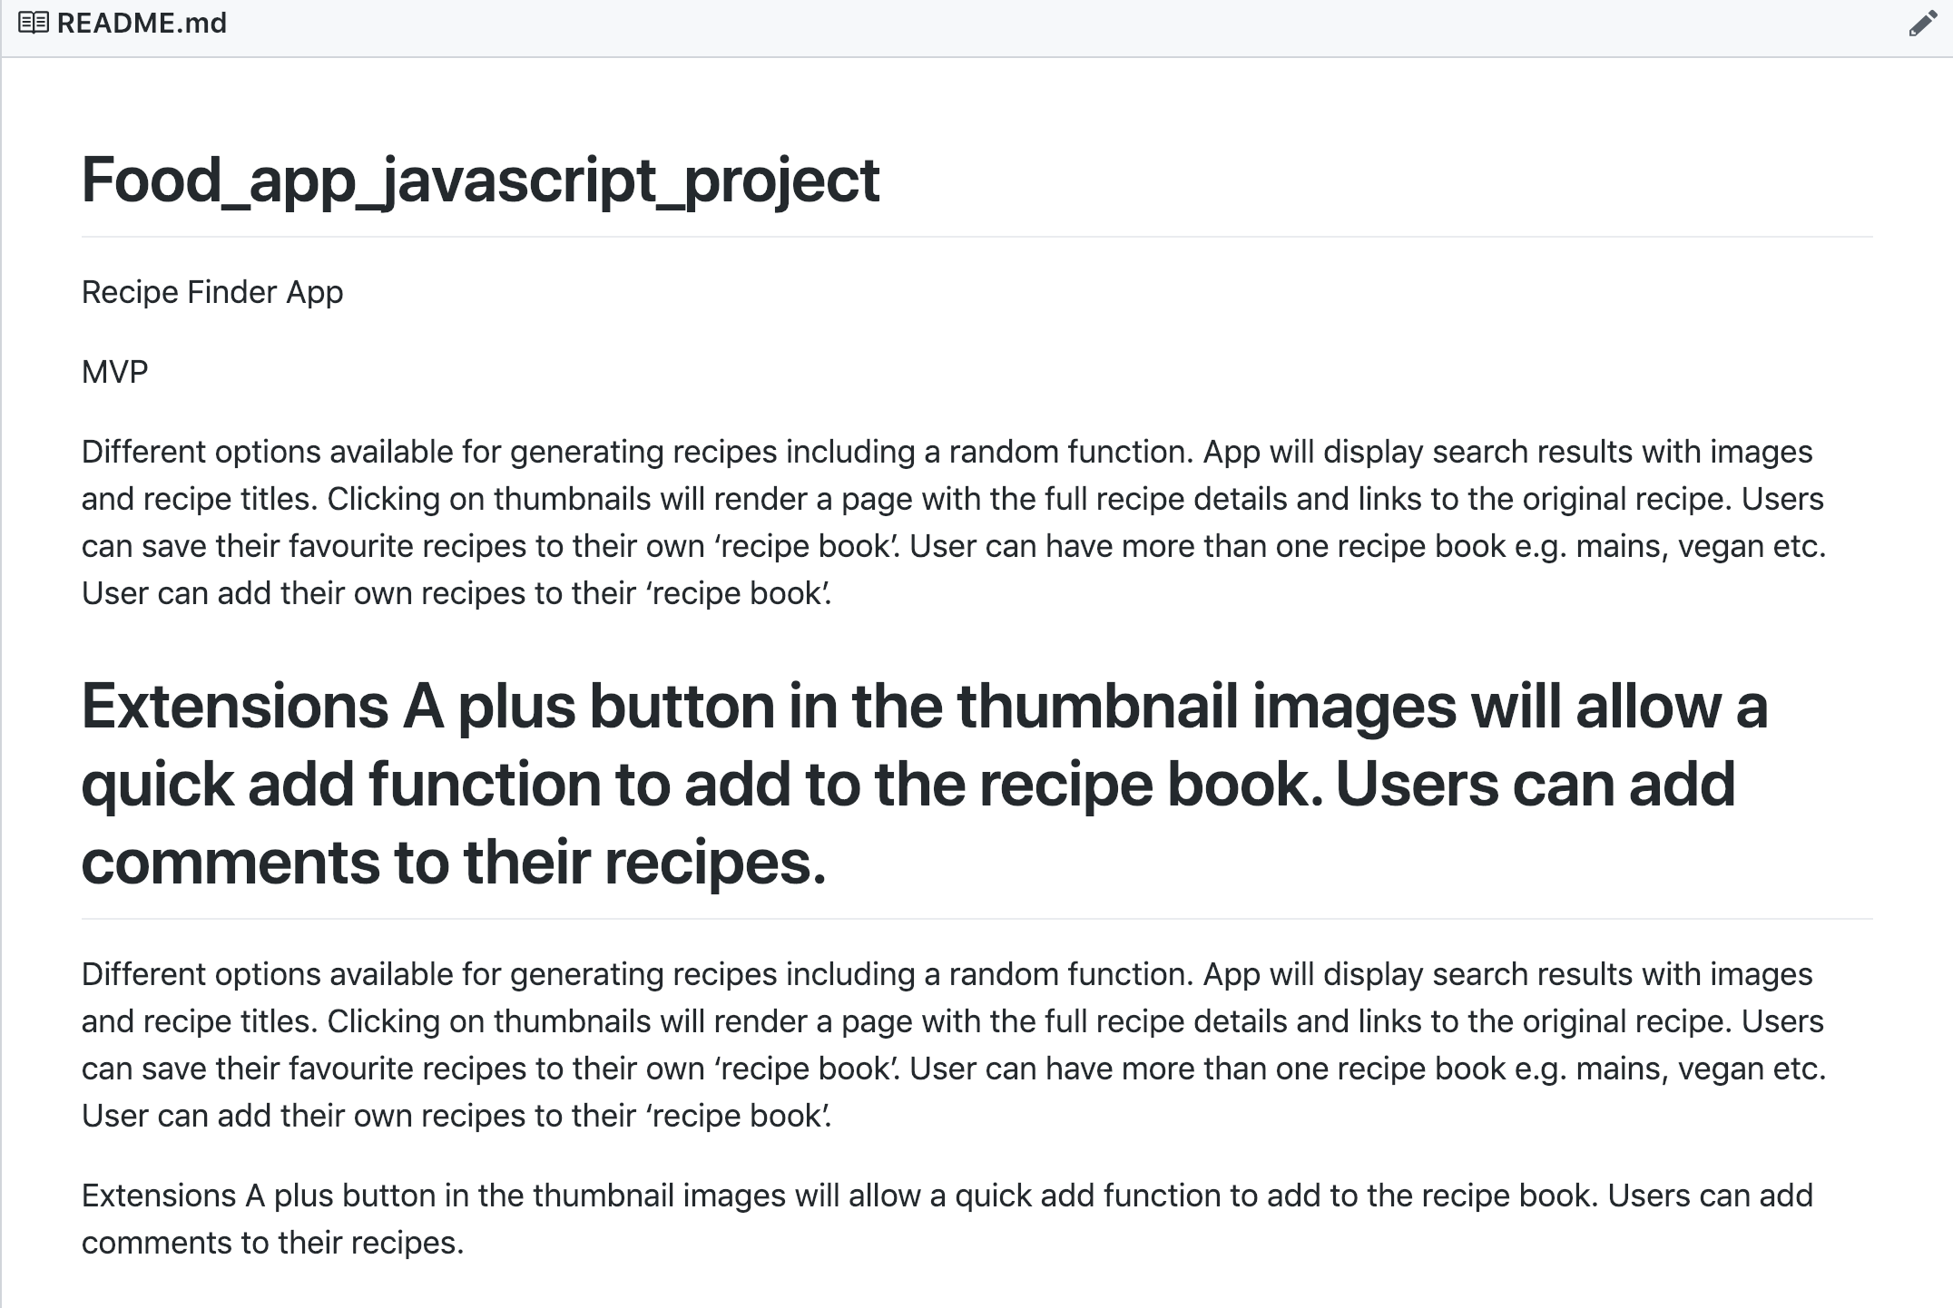

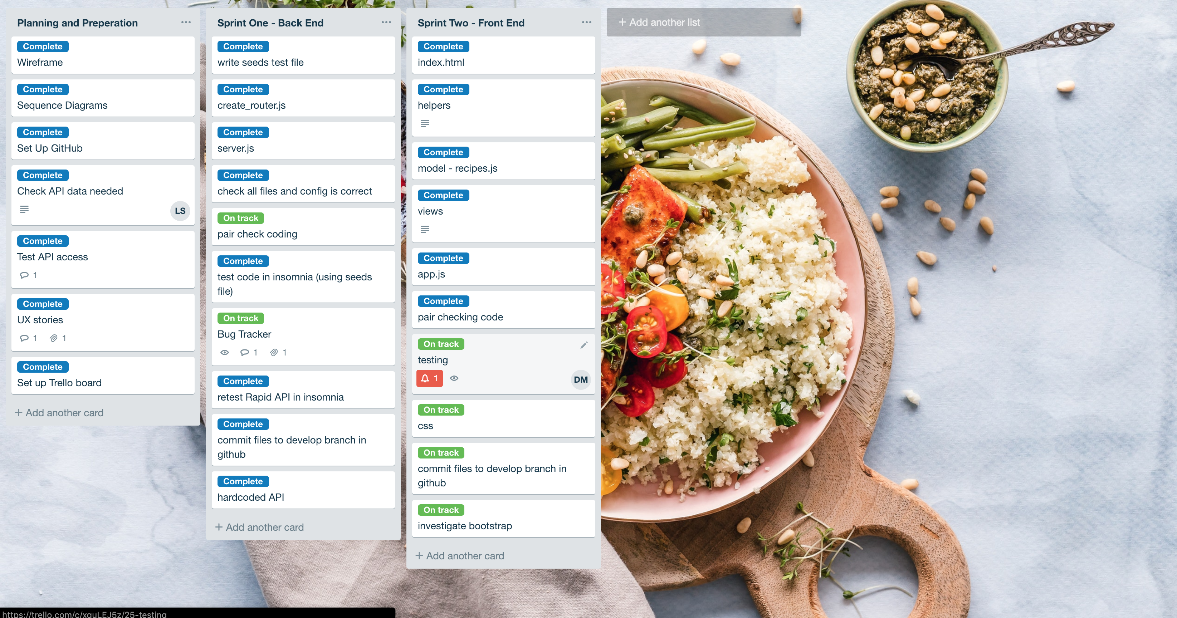

| Unit | Ref | Evidence |  |
| --- | --- | --- | --- |
| P | P.3 | Provide a screenshot of the planning you completed during your group project, e.g. Trello MOSCOW board. | |
|  |  | **Description: our trellio board for our JavaScript recipe project. Done over 3 sprints** | |

| Acceptance Criteria | Expected Result/Output | Pass/Fail |
| --- | --- | --- |
| A user is able to view a random selection of recipes from the site. | The home page renders a random selection of six recipe each time the user lands on the home page. | Pass |
| A user can select a recipe they want more details for. | Taken to the recipe page giving details of the ingredients recipe etc. | Pass |
| A user can search the site for recipes within a defined diet type. | The site renders all the recipes within that diet type. | Pass |
| A user can search the site for recipes using an ingredient. | The site renders all recipes which include the specified ingredient. | Fail |
| The user can save recipes to their own recipe book to refer to later. | The site renders a page showing only recipes the user has saved. | Pass |
| The user can add their own personal recipes to their recipe book. | The site adds the recipes to the recipe book and show the recipes the user has saved from the site and those added. | Fail |

| Unit | Ref | Evidence |  |
| --- | --- | --- | --- |
| P | P.4 | Write an acceptance criteria and test plan. | |
|  |  | Acceptance Criteria for our JavaScript recipe add project. This was made at the start of the project. | |

| Unit | Ref | Evidence |  |
| --- | --- | --- | --- |
| P | P.7 | Produce two system interaction diagrams (sequence and/or collaboration diagrams). | |
|  |  | **Description: Systems diagrams displaying how one recipe and multiple recipes will be retrieved.** | |



| Unit | Ref | Evidence |  |
| --- | --- | --- | --- |
| P | P.8 | Produce two object diagrams. | |
|  |  | **Description: one object diagram of an instrument and the other of a job** | |

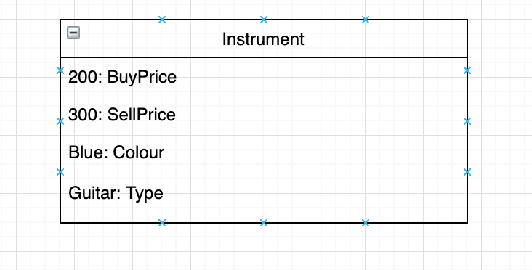

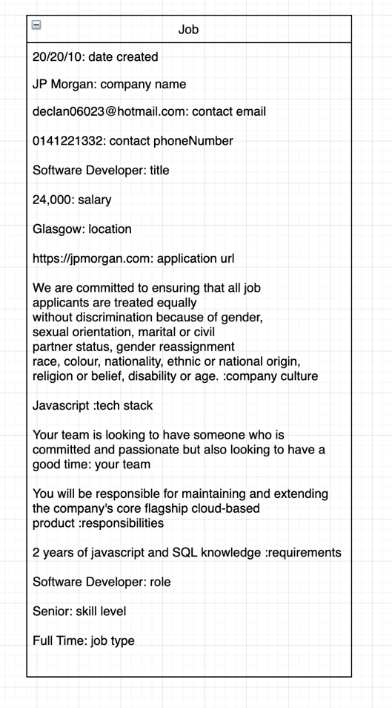

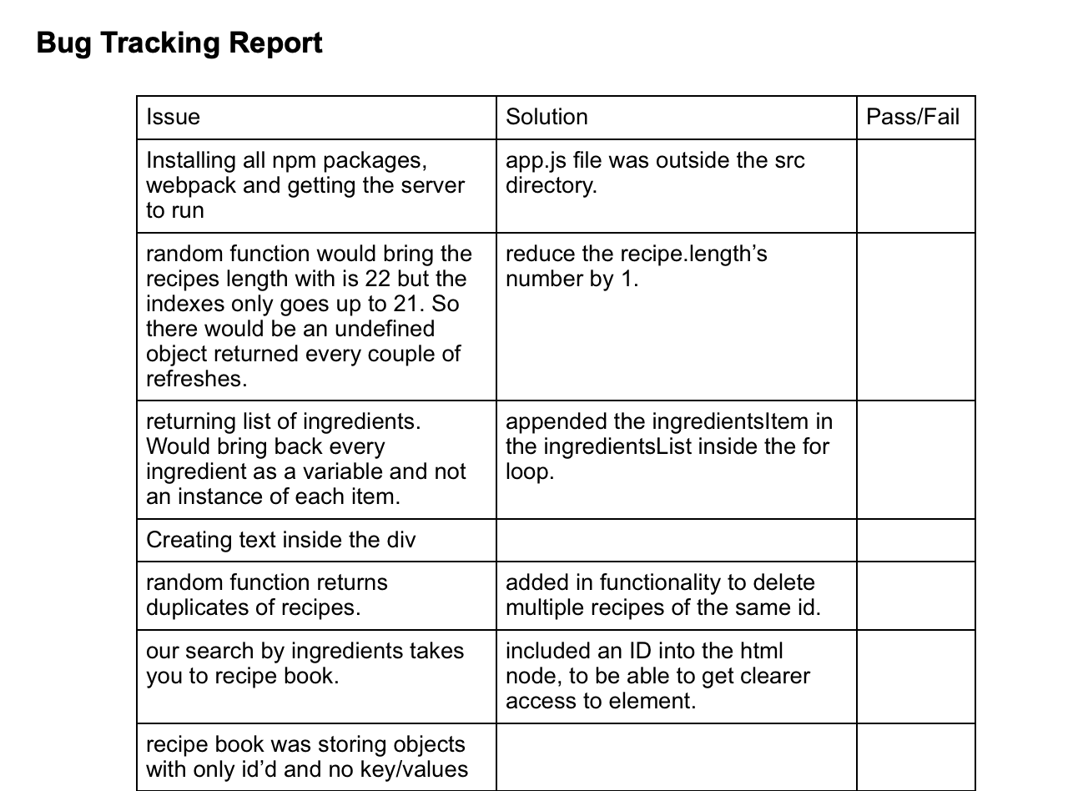

| Unit | Ref | Evidence |  |
| --- | --- | --- | --- |
| P | P.17 | Produce a bug tracking report | |
|  |  | **Description: A bug tracking report that was used to track what issues.** | |

**Week 12**

| Unit | Ref | Evidence |  |
| --- | --- | --- | --- |
| I&T | I.T.7 | The use of Polymorphism in a program and what it is doing. | |
|  |  | **Description: Turning an instrument class into a Guitar object** | |

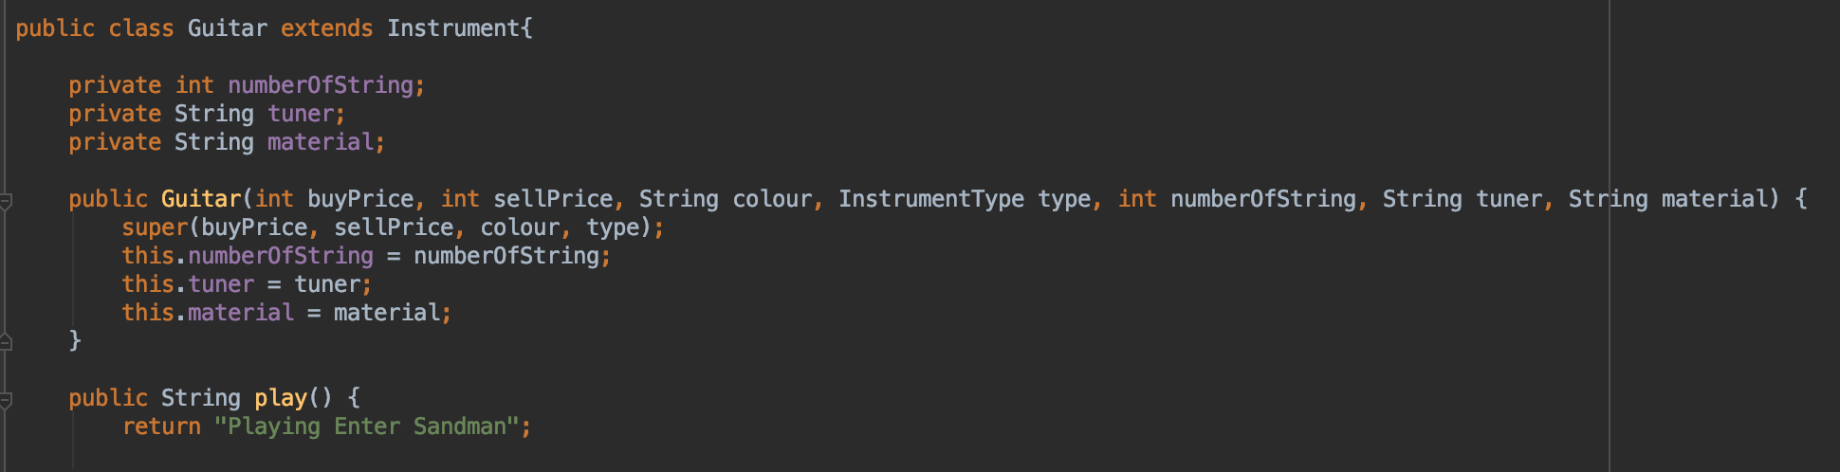

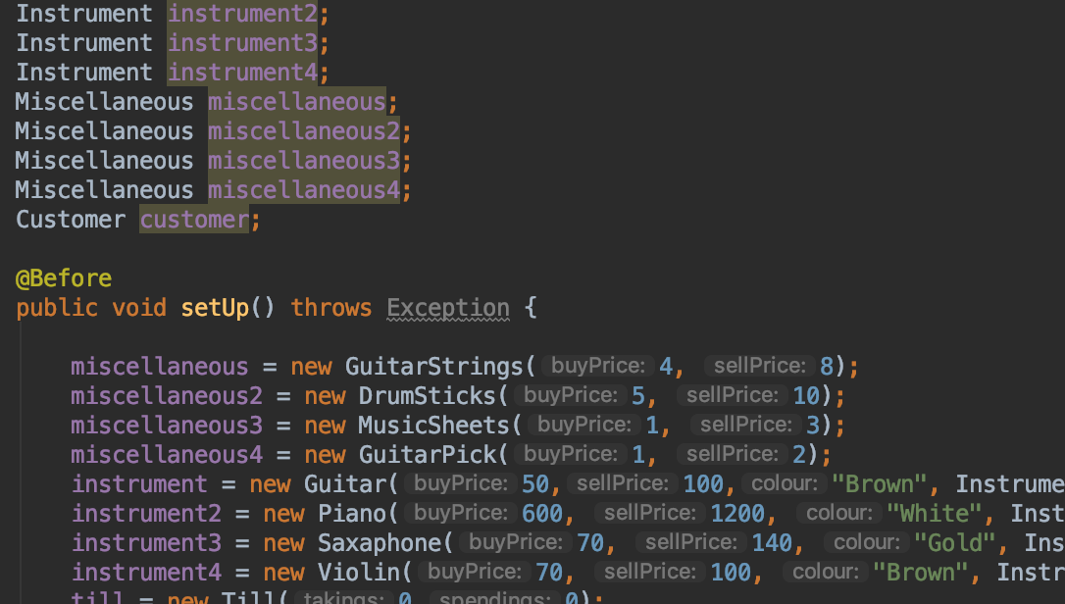

**Paste Screenshot here**

| Unit | Ref | Evidence |  |
| --- | --- | --- | --- |
| A&D | A.D.5 | An Inheritance Diagram | |
|  |  | **Description: The parent class ‘instrument’ is inherited by the 4 different child classes.** | |

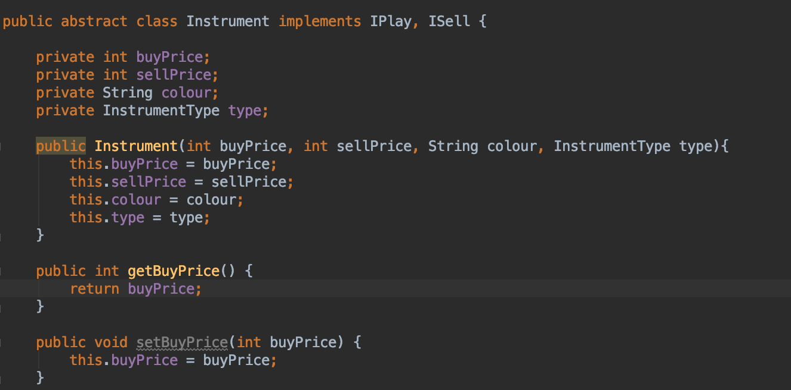

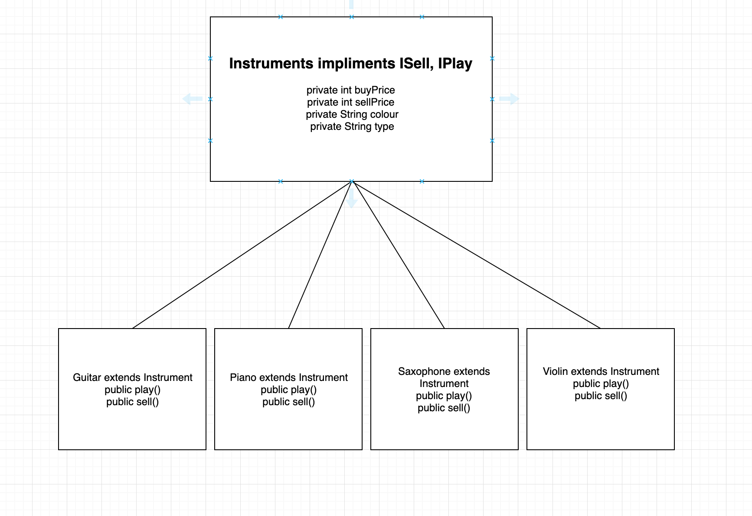

| Unit | Ref | Evidence |  |
| --- | --- | --- | --- |
| I&T | I.T.1 | The use of Encapsulation in a program and what it is doing. | |
|  |  | **Description: the buyItem function encapsulates a function fron the person class and from the instrument class.** | |

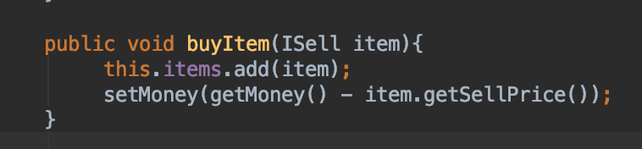

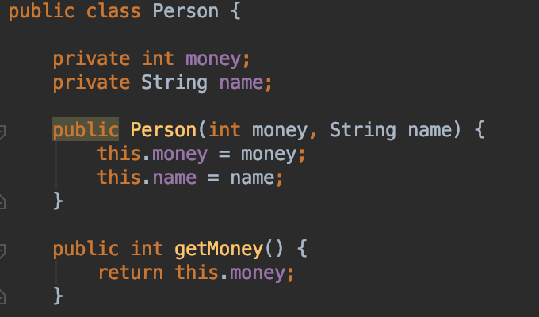

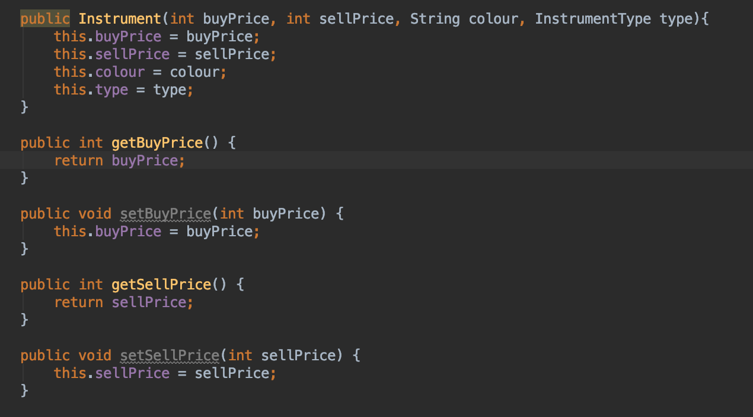

| Unit | Ref | Evidence |  |
| --- | --- | --- | --- |
| I&T | I.T.2 | Take a screenshot of the use of Inheritance in a program. Take screenshots of:  *A Class  *A Class that inherits from the previous class  *An Object in the inherited class  *A Method that uses the information inherited from another class. | |
|  |  | **Description:A display of a guitar inheriting from an instrument and using a function from the parent class.** | |

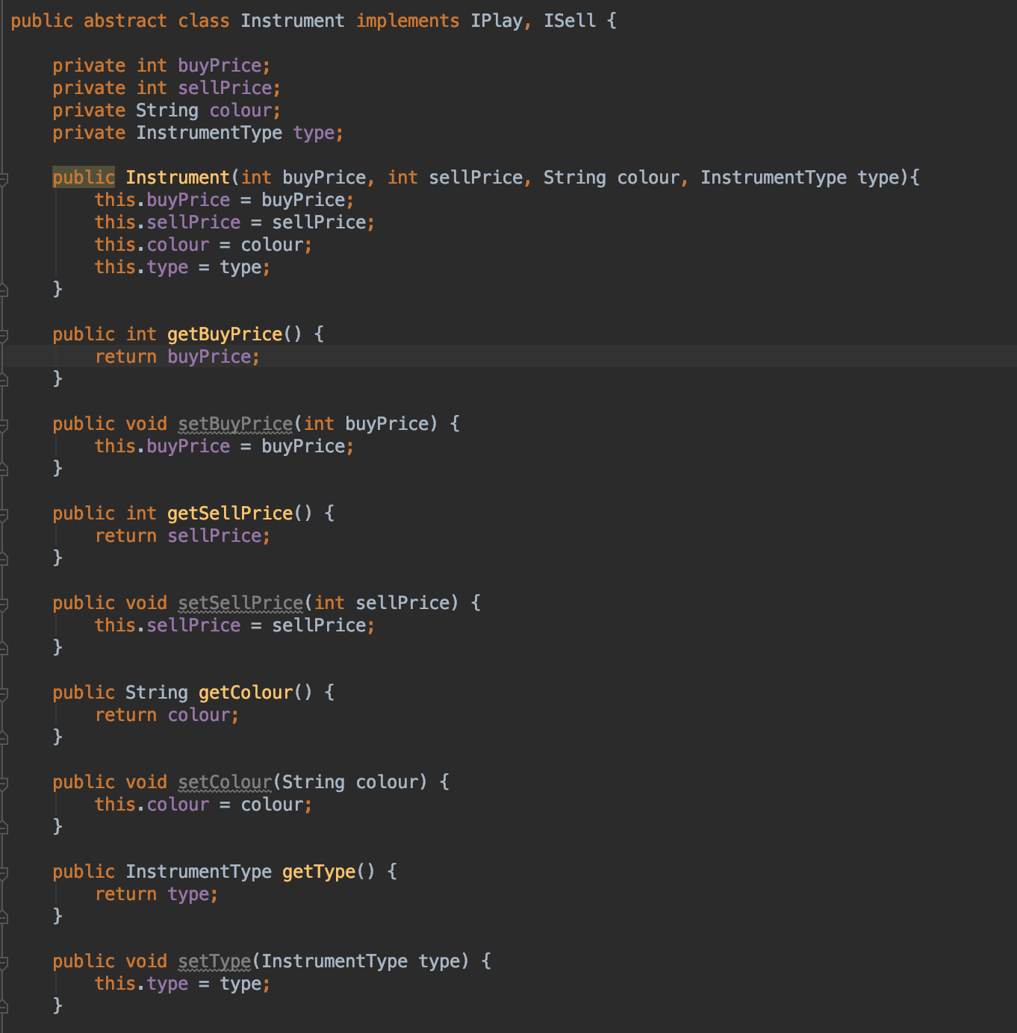

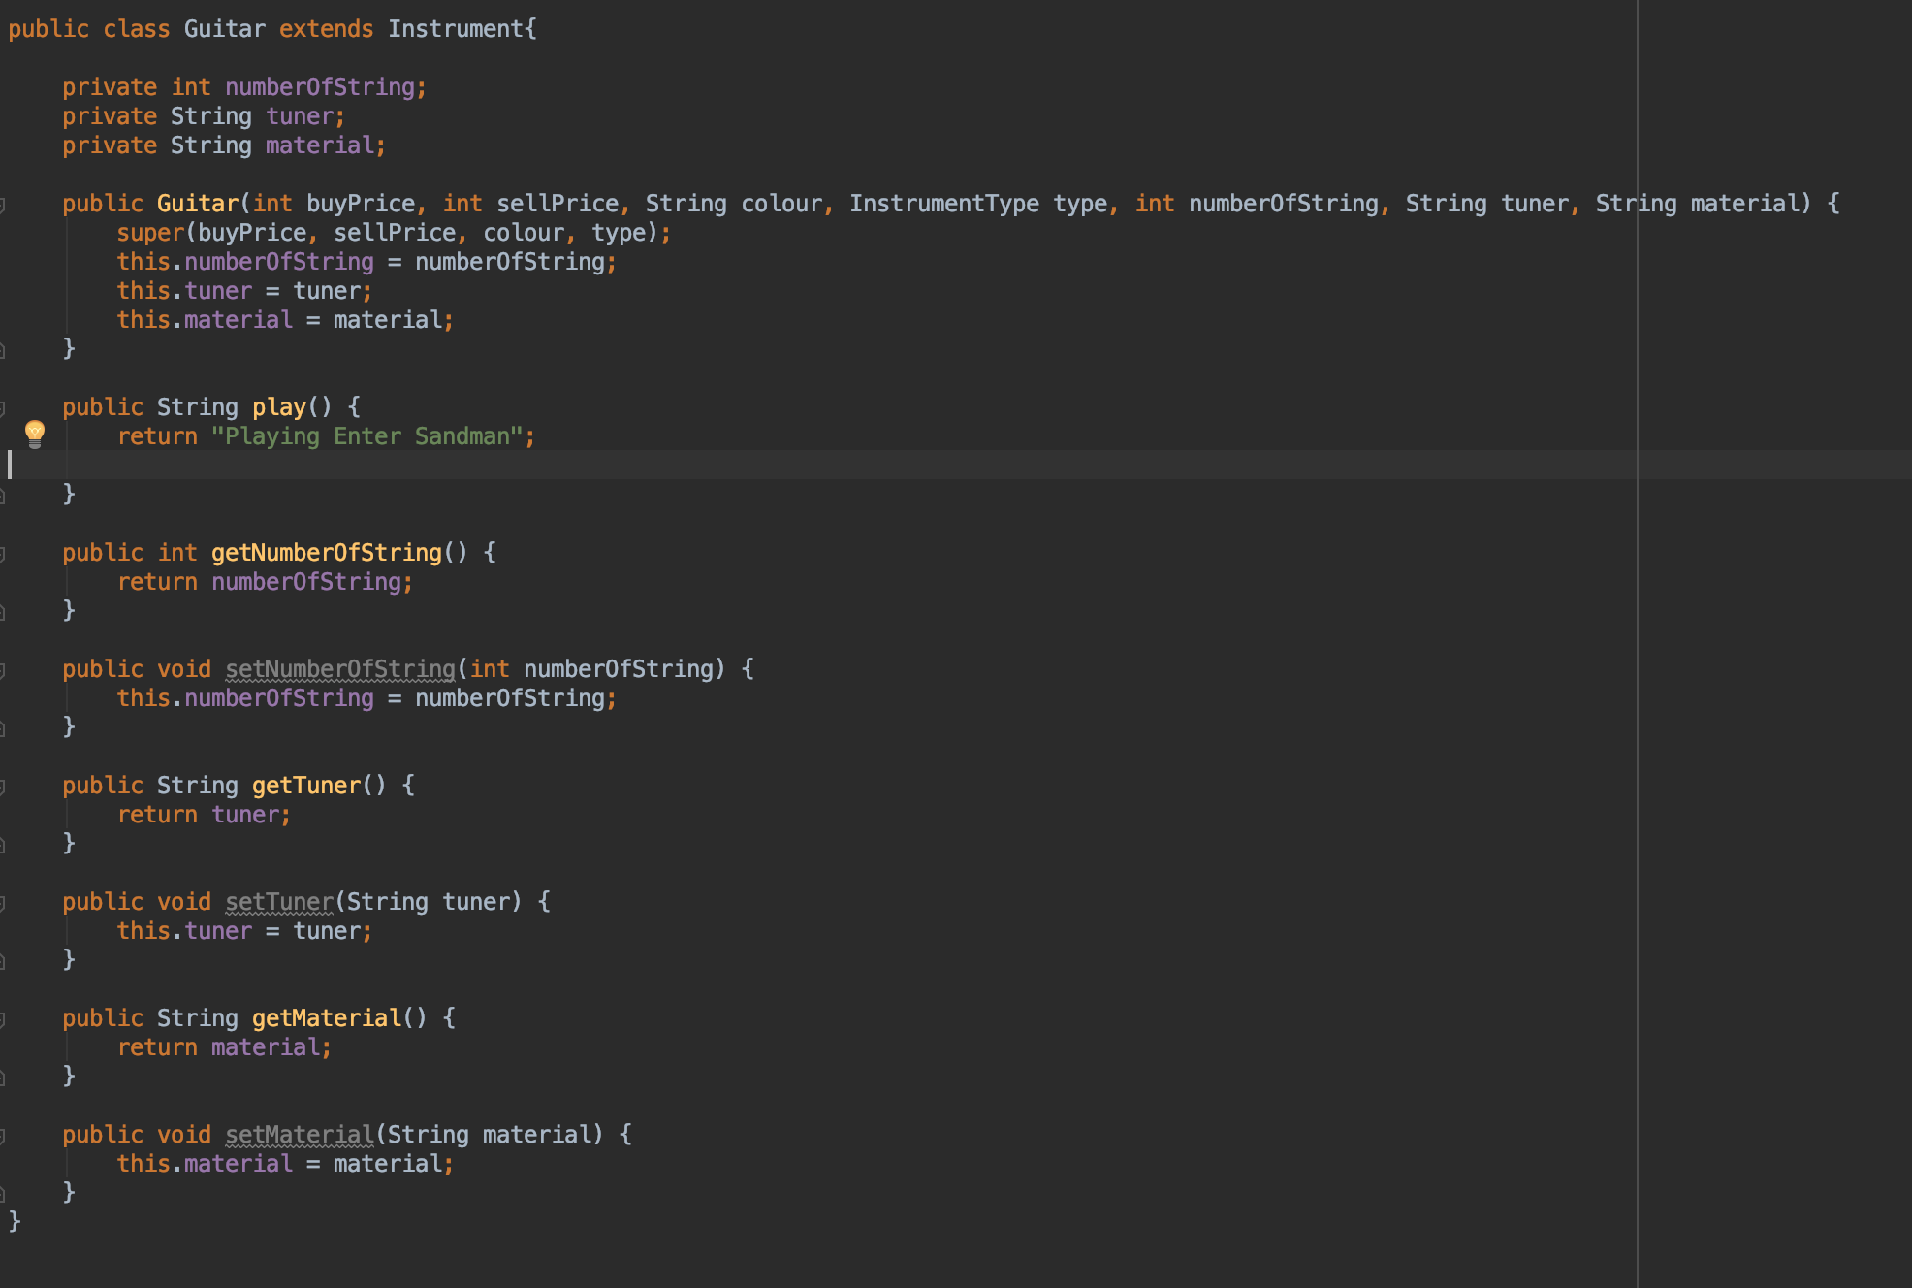

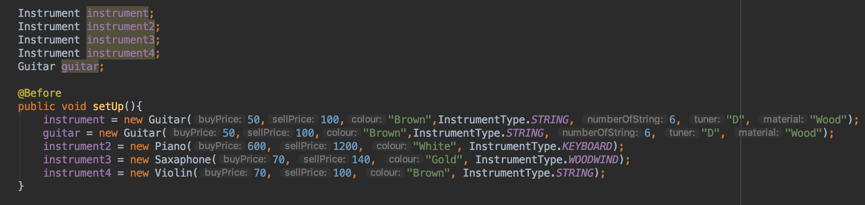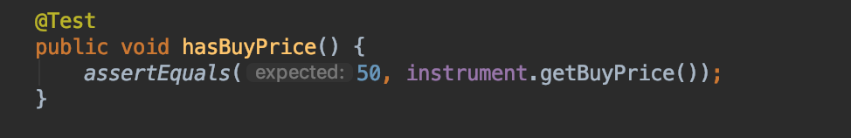

| Unit | Ref | Evidence |  |
| --- | --- | --- | --- |
| P | P.9 | Select two algorithms you have written (NOT the group project). Take a screenshot of each and write a short statement on why you have chosen to use those algorithms. | |
|  |  | **Description: the first algorithm randomises seat numbers for a plane. The other takes random recipes and displays them at the front page each time it is refreshed.** | |

**Paste Screenshot here**



